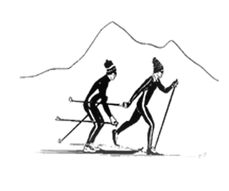
Sierra Regional
Ski For Light
Newsletter
Summer 2020. Volume 16, Issue 1

WHO WEARE?
by
Editor Betsy Rowell

Sierra Regional Ski For Light (SRSFL) is an all-volunteer, non-profit cross-country ski program for blind and visually impaired children and adults. Donations are tax-exempt under section (501)(c)(3) of the IRS code.

The program is a way for blind and visually impaired individuals to promote good health by being involved in a winter cross-country ski program and a summer program, including
hiking and water activities. This newsletter is published annually to provide information about the people and activities of SRSFL.

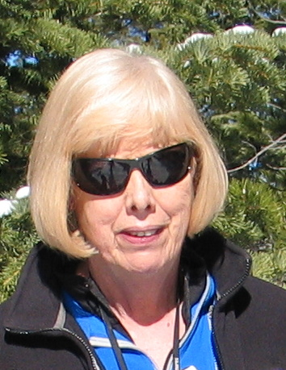
The magic of SRSFL is in all the individual stories and experiences, so please enjoy them.\\

PRESIDENT'S MESSAGE
by
Betsy Rowell, President
Sacramento, CA
The past few months has been a challenging time for all of us. I hope you are all doing well. It is a good time to reflect on the past year with SRSFL, and to start planning for the year ahead.
Last August, SRSFL hikers, guides and volunteers enjoyed a fun time hiking at South

Betsy Rowell, President
Lake Tahoe. The summer hiking weekend has now become an integral part of SRSFL. Unfortunately, this event will not take place this summer, but we look forward to resuming in the summer 2021.
The 2020 ski season was a challenge, but as usual we had a successful 3-day event. I want to thank Cindy Quintana for taking over my job as skier coordinator and other duties for the 3-day event while I was recovering from my broken femur. A big thanks goes out to the Lotts and Gorens for taking over the meal planning for the 3-day event. I am now back on my feet and doing well. And things are already falling into place for the ski season of 2021.
As President, I will focus on getting more involvement from all participants: skiers, guides and volunteers. I would like to encourage more publicity to reach out to skiers of all ages. Fundraising is a big part of SRSFL and I want to encourage everyone to participate in this task. I hope SRSFL will continue to improve as it evolves, and I look forward to seeing you on the snow next ski season. Have a fun summer.

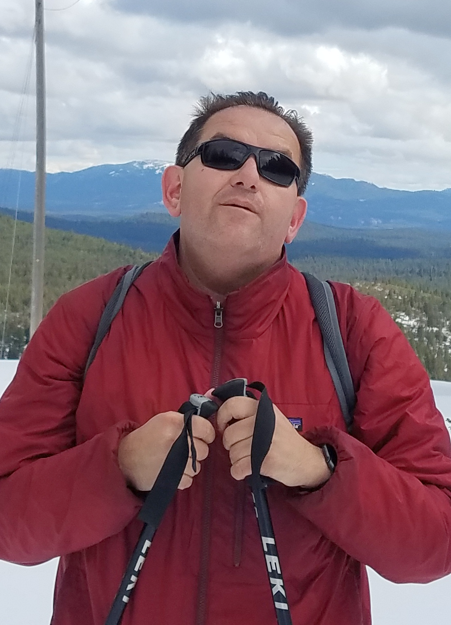
AN AMAZING OPPORTUNITY
by
Richard Rueda
Sacramento, CA

Stomp, Crunch, Swoosh, were some of the sounds and movements heard and exercised during the 2020 SRSFL 28th Annual three-day cross-country ski trip. Twelve participants from the Sacramento and bay area embarked upon the Truckee Donner region for three amazing days of cross-country skiing and snow shoeing.There was just enough snow on the ground, occasional snow flurries, wind and an abundance of sun later in the weekend, our trip could not be any finer. Smiles and determination were evident throughout the weekend while each of us challenged ourselves to ski that extra mile, snow shoe that steeper trail while taking deep breaths and leaving the hustle and bustle of life behind us.
Richard on the snow
Guides and volunteers once again gave selflessly of their time on and off the snow to make this a memorable outing for all. From Edie’s organization and match making of guides and participants and organizing our dinners, praise to a smooth operation cannot be underscored enough. Although I myself do not make this trip annually due to work and life commitments, I truly look forward to attending and fully participating as often as I can.
Thanks to Betsy and the entire SRSFL team and board for providing such an amazing opportunity that otherwise would be extremely difficult to impossible to attain.

In closing, it was nice to see a few new young faces as well as our weathered regulars attend and share in new and old memories. SRSFL is a great organization and my hope is that we will all continue to step in and up to support it and strengthen it for decades to come.

A GRATEFUL THANKS
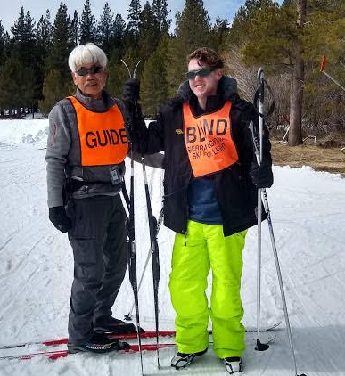
By
Jason Nixon-Patton Elk Grove, CA

I am writing this letter to express my gratitude to you and your organization for allowing me to participate in a ski weekend in Tahoe March 6,7,8 and 9. I am very appreciative of the scholarship which included meals, lodging, equipment, one on one training, and transportation.

I am a beginning skier and this adventure allowed me to be a better
skier and participate in snow skiing. I especially liked having
Guide Kin training me one-on-one. This trip is one that I could have never afforded without your generous assistance and support.

I was able to meet visually challenged individuals in my community and participate in planned meals and activities. We were able to get together and talk about our day. This event gave me the opportunity to meet new friends. I also am a better skier. I am looking forward to next year.

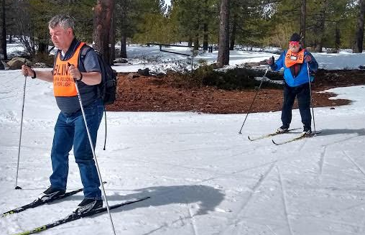

Guide Tom guides Mike on thin snow

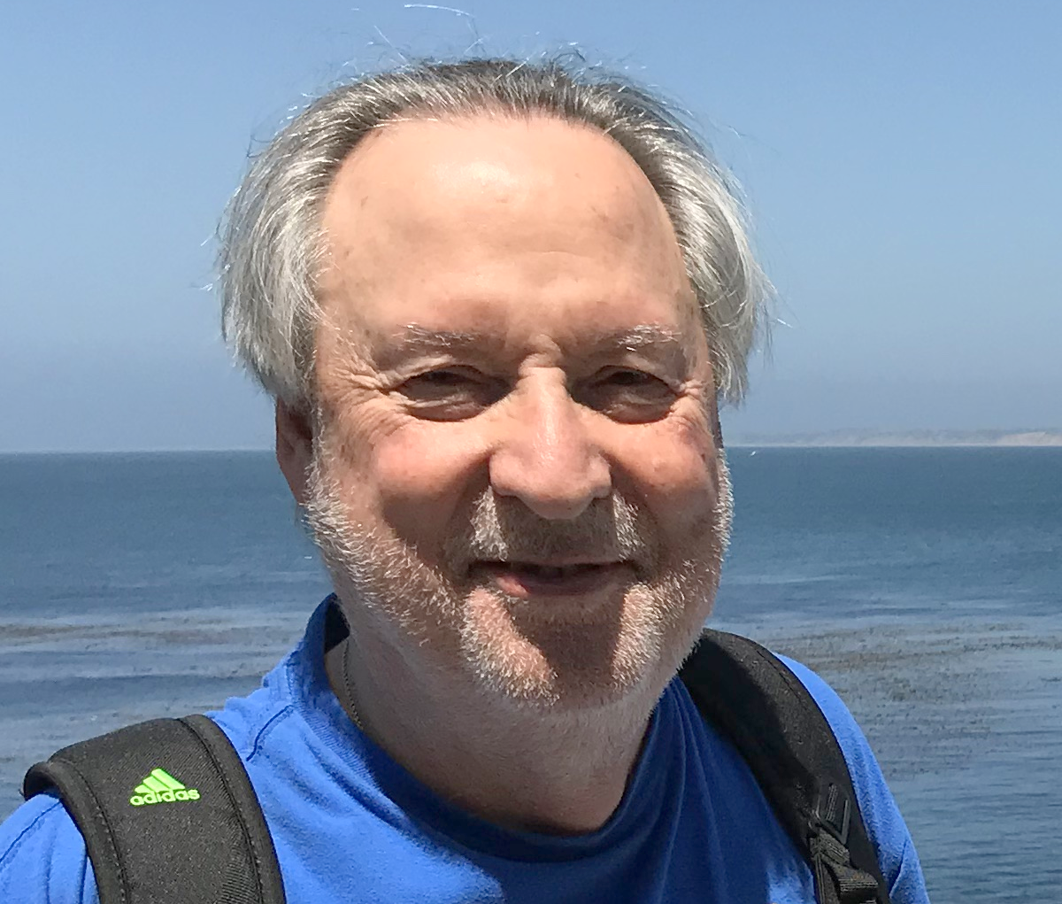
WHY DO I KEEP COMING BACK TO SRSFL?
by
Jon Courtway
Sacramento, CA

Betsy wants to know why I keep coming back. I don’t know why. I have no simple, easyanswer.

I’m not especially outdoorsy. I don’t like hiking in windless hot weather, hiking a steep Sierra grade. Hiking boots hurt and so do thighs, ankles
Jon, Volunteer Extraordinaire
\and feet after a few miles. Sleeping on the cold, hard ground or snow no longer warms my soul. Sharing outdoor camp meals with flies, gnats, mosquitoes, and raccoons is not high on the list either. And climbing a
mountain just to get to the top for the view is a waste. You just have to come back down again, punishing your knees to break the descent.

Why do I return over and over? It’s complicated. There are multiple motivators.It started before Sacramental Regional Ski for Light (SRSFL) and before SacramentoSierra Club’s Inner-City Outings (ICO). It started in first grade in 1950.

Also, the sound of the diagonal stride becomes a meditation: kick, glide, slide andswitch; kick, glide, slide and switch; kick, glide, slide and switch. If I could just do 10 or 20 of these without a stumble, WOW! That was perfection! It was way more efficient than hiking. And by pacing, I could ski uphill without much sweat and be rewarded with both a view and a free ride down.

In the mid 70’s I learned about ICO and its mission to take inner city kids and adultswith no access to the outdoors to the Sierras. A few of us Sierra Club members trained and were certified. We led camping trips for kids referred by Sacramento County Health and Human Services Department.

In the meantime, my environmental awareness grew. For instance, I realized that space engineers have to create space craft that handle human waste, else astronauts poison their own environment. This is the same waste that on earth was being dumped on land and in rivers and oceans. I realized that Space Ship Earth is in real danger!

I also learned that marginalized people (minorities, poor, disabled, single parents) live in neighborhoods with dumps and polluting industries. They don’t have the political cloutor money to stop these projects. The Sierra Club needed to give a voice to them.

Then I met Betsy on a Sierra Club Singles Outing. She tripped and fell in a Manzanitabush and I helped her up. We talked or Betsy did. I learned that the Sierra Club would not let her go X-country skiing because of her visual impairment. They were afraid she’d get lost, get hurt, and they did not want to be responsible. They did not know what to do or how to do it. Since she was being denied access, the very mission of ICO, I asked her to come to our next planning meeting. At that meeting Betsy’s dream was born.

ICO recruited X-country Sierra Club skiers and Betsy recruited VIPs (Visually ImpairedPersons). We trained ourselves. We learned from blind skiers. We found the Ski for Light training manual and used it. We sent guides to Regional Ski for Light for training. We expanded the program to include day hikes, car camping, canoeing, sits-skis forphysically disabled, and tandem biking. We organized, created a board of officers withbylaws, and a treasury to support transportation and ski scholarships. This ICOprogram lasted over 20 years. However, the most important accomplishment was to get blind skiers to provide input at planning meetings and then become officers on theboard.

In 1992 Betsy and others decided to create the Sacramento Regional Ski for Light program. The ICO X-country ski program and all the ski guides transferred to SRSFL.Many of us, myself included, kept feet in both programs.

For over 40 years, I’ve helped people with visual problems worse than mine.Everyyear, Betsy invites me back even though I no longer ski or guide. I can’t say no to beingneeded and wanted. I don’t want to see the light go out on her dream of sharing thebeauty of the Sierras and the snow. I see Betsy’s dream alive and well in the smiles andtriumphs of the participants who accept the challenge to Ski for Light.

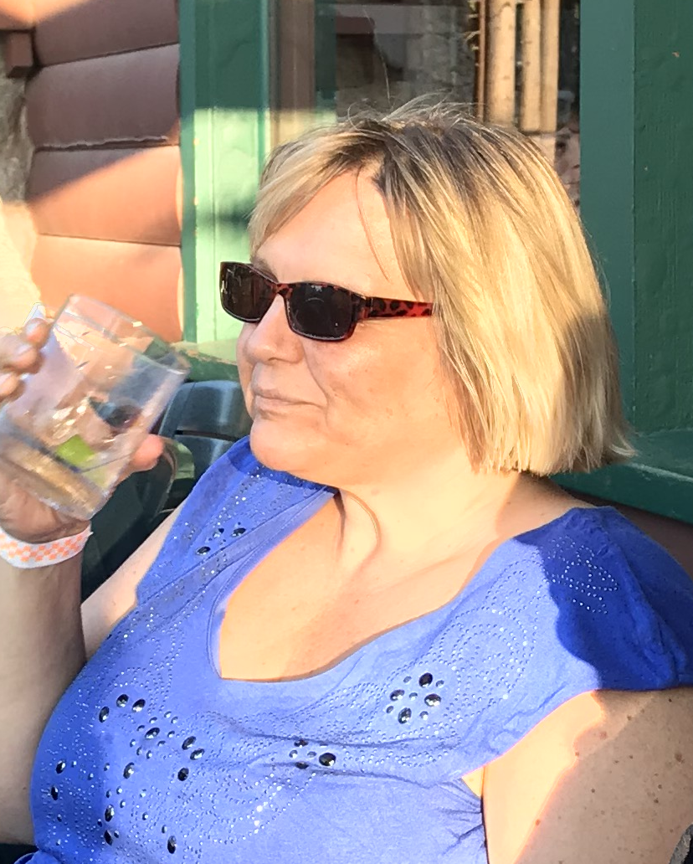
Frosting on the Cake
by
Michelle Goodwin
Shingle Springs, CA

On top of an absolute draining season at work I had just come off of 2 weeks of traveling. (1) To see my family who I hadn’t seen in years, and (2) for a work conference. Anyone who really knows me knows that I get refreshed, relaxed and rejuvenated from the outdoors. So, when I heard about theopportunity to go for a hiking weekend
Michelle enjoys a cool drink.

in the Sierras for such a great price, I gotso excited. Plus, frosting on the
cake, a new friend I had made and wanted to spend more time with wanted to go also. Neither of our partners could go, so we decided to make it a girl’s trip and join the regional Ski for Light on their long weekend summer hiking trip.

We had heard great feedback about this weekend from those who had gone before us. To tell the truth I almost didn’t make it after such life craziness, but off we went. The lodge was great, comfortable and modest right near the water of the lake with a beautiful deck. We were able to chill outif we wanted, be by ourselves or socialize. Organizers and volunteers were empowering and not demeaning. The guides were great at adapting to each of our needs. I had done a lot of hiking in the past, but due to health issues this out of shape woman was nearly starting over. The coordinators and volunteers were great at adapting each day to what we needed, and a very refreshing time was had.

My friend and I got to know each other more, had some adventures on our own and despite our fatigue from life and other things we got to hike ourselves in the quiet mountains. This was our first activity with the Regional Ski for Light and we both are eager to be a part of its future. Especially its hiking weekend in the warmer season!

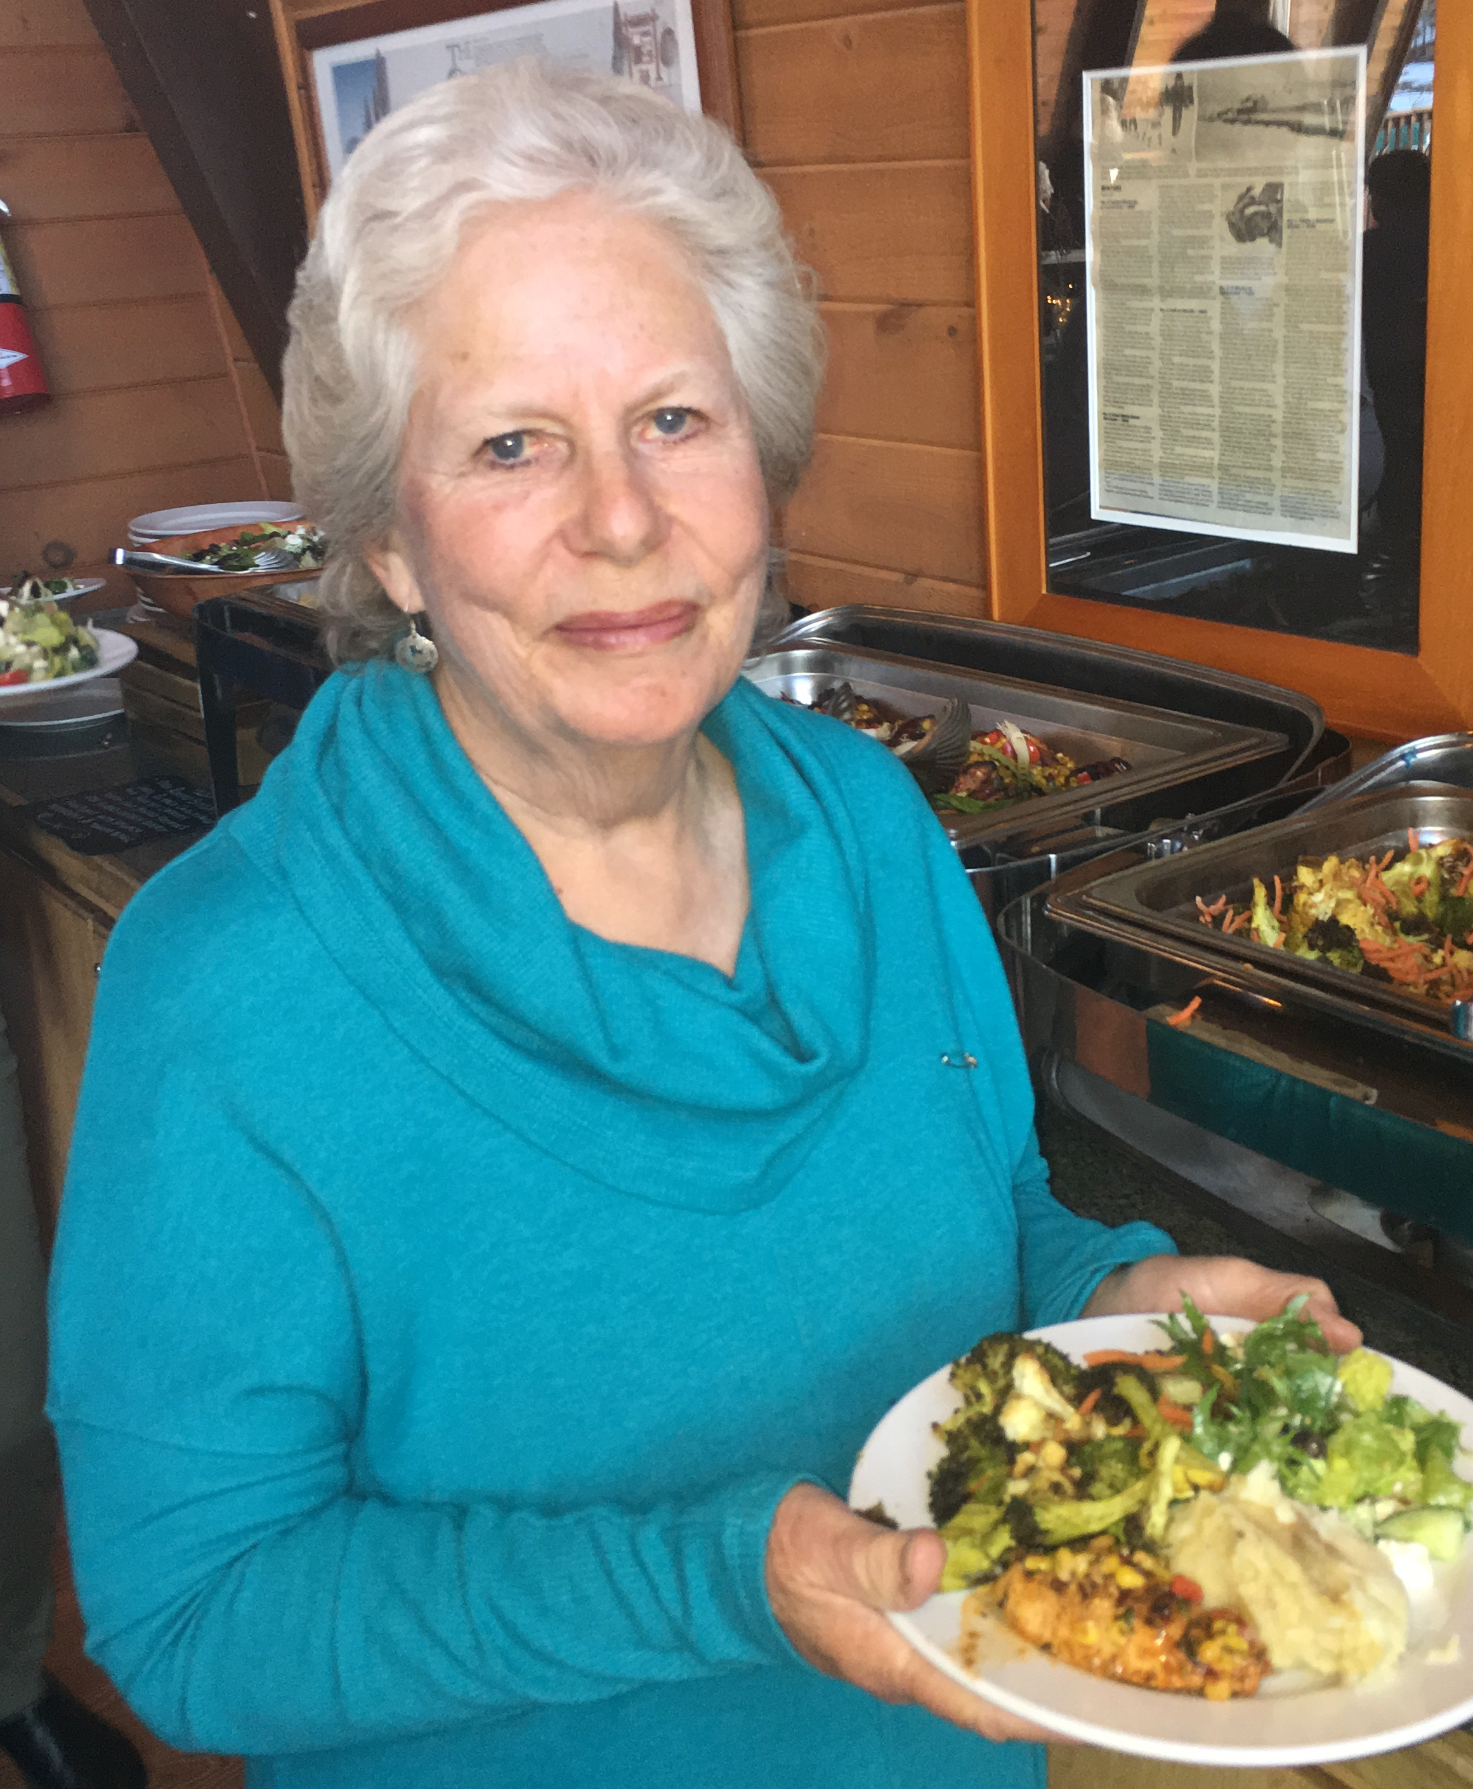
2020 SRSFL, ANOTHER 3-DAY EVENT TO REMEMBER
by
Edie Lott, Guide Coordinator and Web Master
Truckee, CA

Our event was to be held on March 7-9 just as the Covid 19 Pandemic was rearing its ugly, scary head. From the beginning, we faced many obstacles from lack of snow to lack of skier participants. For a while, the discussion was to cancel,or go ahead. The snow came and the skiers slowly signed up. We were a go!
Edie enjoys dinner after along day

While the group was smaller than usual, everyone had a fabulous time. With help from volunteers the Gorins and the Lotts pulled off the dinners. Thanks to Tom finding Smokey’s as our caterer, the food was great! The snow was better than we expected. The guides came through and did an amazing job! Our 2020 3-Day Event was meant to be! Had it been scheduled for one week later; it would have been canceled by Tahoe Donner because of Covid 19! For me it was days well lived. I’m looking forward to next year’s event.
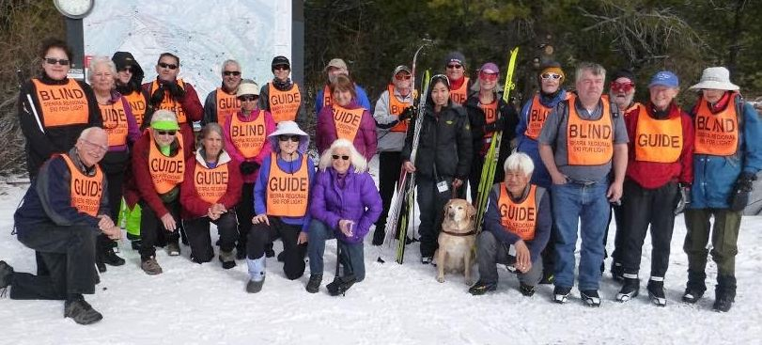
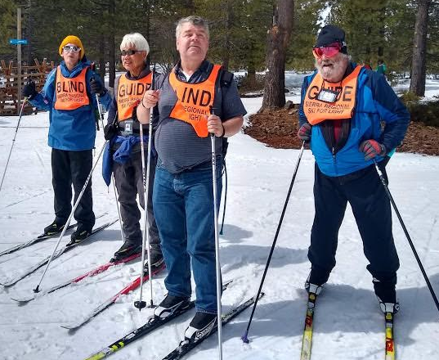

MARH 2020 3-DAY EVEN
THE SRSFL BOARD OF DIRECTORS

PRESIDENT: Betsy Rowell
E-mail: betsy.rowell2@gmail.com

VICE PRESIDENT: Edie Lott
E-mail: thelotts@gmail.com

SECRETARY: Sue Mangis
E-mail: susanmangis@comcast.net

TREASURER: Jean Snuggs
E-mail: snuggsj@gmail.com

MEMBERAT-LARGE: Tom Gorin
E-mail: tdssg@gmail.com

MEMBER-AT-LARGE: Shawna Ramsey
E-mail: shawna2020@sbcglobal.net

IMMEDIATE PAST PRESIDENT: Vickie Post
E-mail: VickiPost@earthlink.net
FUNDRAISING

Fundraising goes on year-round. Fundraising
may seem like a bit of a mystery to many of
us, but it is one of the most vital elements to
ensure SRSFL's bright future. Now that summer activities have been added to the
program, extra funds are more critical thanever! So, anything you can do to help will be
greatly appreciated. We are seekingsupporters, donors, grants and cash. All money
raised goes directly into the program fortransportation, scholarships and other expenses,
and to keep the cost down forall. Signing up for Amazon Smile is another way for SRSFL
to raise money. Go to Amazon and choose SRSFL as your charity.

If you have questions, ideas and/or suggestions please contact Betsy Rowell, chair of the
fundraising committee. Phone: (916) 362-5557, Email: betsy.rowell2@gmail.com
SRSFL would like to take this opportunity to thank the many organizations and
businesses for their support of our cross-country ski program and summer outings.
Please let them know how much you appreciate their support by patronizing them
business and supporting their other activities.

Active 20/30 Club No. 1 of Sacramento
Auburn Host Lions Club, Auburn, CA
Commerce Printing, Sacramento, CA
Embarcadero Lions, Sacramento, CA
Folsom Lake Lions, Folsom, CA
Grant from the Peninsula Endowment (one-time grant)
49er Ski Club, Sacramento, CA
Kiwanis Club of Citrus Heights, CA
Kiwanis Club of Folsom, CA
Lions Education Foundation
Sacramento Turn Verein Actives
Sacramento Valley Sertoma Club
Tahoe Donner X/C, Truckee, CA

MANY THANKS also to the individual donors who have supported SRSFL throughout the
years.

2020 – 2021 SRSFL CALENDAR

SUMMER HIKING WEEKEND

We regret that the SRSFL’s hiking weekend has been
Been canceled this year.
If you have any questions, contact:
Vicki Post
415 928-2711
E-mail: VickiPost@earthlink.net

SKI GUIDE TRAINING

Dates and times not yet scheduled. For guide training information contact:

Edie Lott
Home: 530 582-5362
E-mail: thelotts@gmail.com
or
Vicki Post
Home: 415 928-2711
E-mail: VickiPost@earthlink.net

2021 SRSFL SKI SCHEDULE

DAY TRIPS FOR CHILDREN AND ADULTS
Dates have not been scheduled. Consult theSRSFL web site for updated ski
schedule.:

29THANNUAL 3-DAY EVENT

February 6,7,8, 2021

For more information contact

Betsy Rowell
Home: 916 362-5557
betsy.rowell2@gmail.com

KEEP IN TOUCH

SIERRA REGIONAL SKI FOR LIGHT
c/o Edie Lott
10435 Royal Crest
Truckee, CA 96161
Phone: 530 582-5362
E-mail: thelotts@gmail.com

We are on the web
www.srsfl.org

