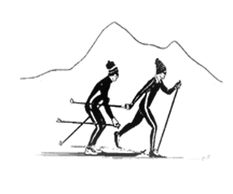
Sierra Regional
Ski For Light
Newsletter
Fall 2018 Volume 14, Issue 1

WHO WE ARE
by
Betsy Rowell, Editor

Sierra Regional Ski For Light (SRSFL) is an all-volunteer, non-profit cross-country ski program for blind and visually impaired children and adults. Donations are tax-exempt under section (501)(c)(3) of the IRS code.

The program is a way for blind and visually impaired individuals to promote good health by being involved in a winter cross-country ski program and a summer program, including hiking and water activities.

This newsletter is published annually, to provide information about the people and activities of SRSFL.

ZEPHYR POINT 2018
HIKING WEEKEND
by
Vicki Post, PRESIDENT, San Francisco, CA

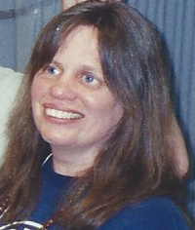
Last May, we put out the call for our upcoming hiking weekend, to be held from August 24-27 at Zephyr Point. This was our sixth annual hiking weekend, so I thought I knew the planning rhythm and what I might expect. What a surprise! In no time flat, we were down to a waiting list. In mid-June, Betsy and I were already scrambling to find enough guides and drivers. This was unheard-of in the past. And, just to keep us on our toes, things changed over and over through the summer until we all arrived on Friday evening to begin what turned out to be quite a magical weekend.

Yes, we are all human and so there were some up and down moments, but in many ways, this was the best one yet with much to celebrate. President, Vicki Post

And so, just for fun, here are just some of the many things worth celebrating:
** We had the largest number of attendees this year, both human and canine: seven dogs and thirty eight people!
** More visually impaired hikers than ever went for the longer hikes, and some of them even exceeded the goals they had originally set for themselves.
** We had four first-time dogs, seven first-time visually impaired hikers, and six first-time guide/volunteers. Welcome, and we hope to see you all again, either on the trails or even on the snow!
** The best dinner to date in the dining room on Saturday
** The absolute best and fastest clean-up crew ever, with many of you distinguishing yourselves here; thank you!
** Great camaraderie out on the deck before dinners
** Excellent food and very gracious volunteers who cooked, prepared and served it
** Monte joining us for Sunday night dinner after successfully making it up Mount Everest, otherwise known as the stairs in front of the lodge
** An amazing group of people who pitched in and brought all the love and joy they could to this weekend
** And we will not talk about yellow jackets!

We especially want to again thank all the guides, drivers and volunteers who so generously gave of their time and energy, making sure the visually impaired hikers had what they needed, got where they needed to go, and were able to stretch themselves and enjoy the outdoors. And to everyone, thank you again for your unique contribution to this incredible weekend; it would have been different without you.

And yes, we plan to do it all over again next year, so stay tuned.

Meanwhile, winter will be here before we know it, so let's make this upcoming ski season as great as the hiking weekend in that great SRSFL tradition. And may you all find magic in the outdoors wherever you live.

EXPERIENCES OF SOME FIRST TIMERS
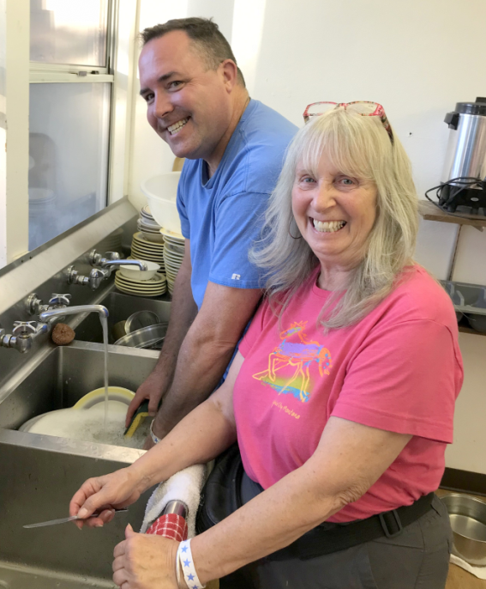
GOING UP A MOUNTAIN WITH
SIERRA REGIONAL SKI FOR LIGHT
By
Chris Fendrick, VIP Hiker, Bakersfield, CA

I got a little idle in my recreation and leisure time. So, I started exercising more and getting out of my house. But, I wanted to hike again and get to the mountains. My Retinitis Pigmentosa (RP) had progressed to a point that I could no longer take myself to the mountains to get on the trail. Yes I have
family and friends that could take me,
Chris helps Cyndy in the kitchen.
But I wanted to do it on my own, and wanted to meet other blind and visually impaired people along the way.

I mentioned my desire to a good friend, Richard Rueda, about this desire and to my surprise, he forwarded me an email about the Sierra Regional Ski for Light program that has a three-day hiking weekend in Lake Tahoe for blind and visually impaired people. Some contacted the Ski for Light coordinators, Vicki Post and Betsy Rowell, to inquire about the trip. This was mid-spring and I was excited to get up the mountain to tackle some hills. For a very reasonable $150, I sent off my check to secure my spot. Then the summer came and school was about to get started again. As a teacher, I fretted about taking off a couple days for travel time to Lake Tahoe. But, I knew a couple days off of work would be worth the fun of hiking the Tahoe region and was I right!

After a mild, long Amtrak ride up the San Joaquin Valley to Sacramento, I met my first volunteer, Don. We had a quick lunch and connected with San Franciscans, Bill and Bea, at the train station.

We headed up Highway 50 to the Presbyterian Convention Center at Zephyr Cove. After arriving, we met up with many more fellow hikers and volunteers. Everyone was coming together mixing and getting to know each other. Some were old friends, some new friends it was exciting to meet new people and ponder what experiences were ahead of all of us. We then settled into our cozy Lakeview lodge and met our roommates. After a bit of time, we headed off to the Zephyr cove restaurant. We descended on the restaurant with sighted guides, dogs and all of us ready for a feast. It was amazing how our common bond of blindness brought us together into this special fraternity and sorority. It was definitely an unspoken bond of blindness and recreation and leisure bringing us together. So, after dinner, we had some social time; then it was time to receive our hiking options and get ready for the morning hike. All of the hikers and volunteers gathered in the common area to get all the orders. It was like we had known each other for years-- joking, cajoling and laughing with one another. We had the choice of challenging, moderate and easy. I chose the moderate, and was paired with
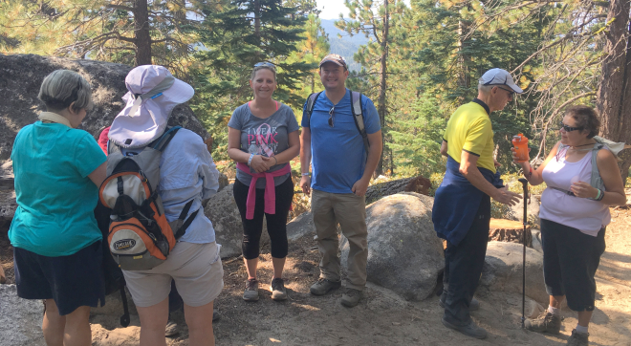
Steve as my guide, Gena a fellow BVI hiker and her guide Lobo.
Is it time for lunch?
We awoke early in the morning to the smell of the woods, bacon frying and coffee brewing. There is no other smell in the world like it. We all came together for a group breakfast. Volunteers help serve the food and everyone enjoyed a hearty freshly cooked meal by Cyndy and Karla. They did a great job of feeding 35+ people! After breakfast, we got in our groups, and piled into the various vehicles.

We arrived at Spooner Lake trail which boasts more than 50 miles of hiking trails and many recreational activities. One group headed up the challenging Marlette Lake trail, while Steve, Lobo, Gena, myself and my guide dog Maximus headed up a moderate hike to a campsite for lunch. The air was cool and the hike was moderate and rolling a bit. There were many mountain bike riders headed up the hill to catch the world-renowned Flume mountain bike trail. But, everyone was very courteous with “good mornings.” We hiked about four and a half miles into where it was time to eat lunch. We found a serene quiet campground off the trail to have the sack lunches that we prepared that morning. This group of four recent strangers settled in for a rest and chatted about our lives back home, our professions, how we got involved with this group and just enjoyed Mother Nature. It was simple and uncomplicated to just share the outdoors and our company. It was time to head back.

We arrived back at the Lakeview Lodge and rested for a few minutes. Gena, Margie and I had signed up for the afternoon boat ride on Lake Tahoe. One of the volunteers, Jim, had offered his boat to take us out to enjoy the lake. We arrived at the dock with our guides, with the strict instructions: no shoes and no dogs. Maximus was bummed, but he was in good hands back at the lodge. We received our safety instructions and boarded the boat. I never did ask Jim the name of his beauty.

We were off. I kept commenting to Gena and Margie that the engine was just wanting to open up and release its power. But, it was a bit choppy and other boats were around, so we just enjoyed the “three-hour cruise”. Smiley. Actually, it was only about an hour. Jim gave all of us an audio guided tour of the facts of Lake Tahoe, the scenery around us and his dream house. It was blissful. We all chatted and got to know each other more and more. We arrived back on shore where we disembarked off the boat. Some of us had some really cool moves getting off the boat, since it was so wavy. But it was fun.

Everyone had some quiet time before dinner. Some napped, showered, called family, or just relaxed. We came back together before dinner for some libations. We continued to laugh and share in the camaraderie of the weekend. It was now time for dinner. Cyndy and Karla were off the hook tonight for dinner since the camp area had a cafeteria where we had a well-prepared tri-tip dinner. It was great because it again mixed us up to meet more of our group and even other campers from areas of the world. The campers with other groups seemed very impressed with this group of blind and visually impaired people who were out hiking and enjoying the outdoors. One woman from Montana kept crying and saying how beautiful this was. I just kept thinking-- big deal lady, our eyes don’t work so well. Doesn’t mean we can’t hike, eat, laugh and enjoy nature. But, she was very nice and I think we left a lasting impression on her.

Saturday evening was similar to Friday night, in which we chose our next hike as Vicky so patiently took our requests. So, it was off to bed to get some well-deserved rest.

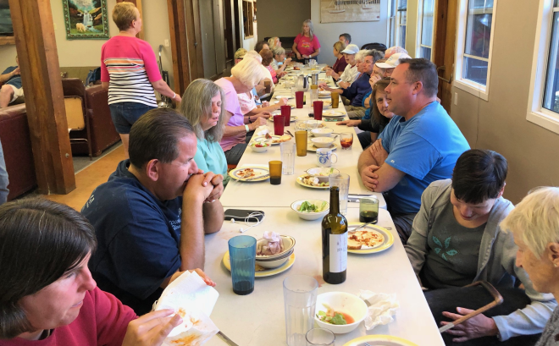
Sunday, we arose again to a wonderful breakfast consisting of fruit, frittata, sausage, coffee, and juice. Margie had heard about a new hike at Whale Beach which we headed out to find. After a frolic down Hwy 50, we couldn’t find it. So, we headed back to Spooner Lake. We broke off into two groups to take the 2-mile hike around Spooner Lake. Steve, Maximus and I took off and I was pleasantly surprised by how tranquil the hike was, with Quaking Aspen all around us shaking in

A delicious dinner after a day of hiking

the breeze. It was an easy trail, with signs posted at various places along the hike to explain the history, nature and fun facts about the area. It was just my speed for the day, since I was recuperating from the nine miles the day before. But, it was also nice just because it was getting away from the hustle and bustle. I enjoyed lunch by the lake, eating from my sack lunch and just chilling with Steve and Maximus.

After the hike, we returned to the lodge for just some downtime. Some people went swimming in the lake, some napped and others were finishing up their hikes. We all congregated on the deck to enjoy the cooling temperatures, and some enjoyed snacks and wine. Then, it was time for dinner, and we assembled again at our family style dinner, and laughed and talked about the day.

Monday morning came very quickly. The sound of the vacuum cleaner came early, with all of us beginning our chores to clean up and ready ourselves for the road. I was fortunate to get an earlier ride back to Sacramento, and get an earlier train back to Bakersfield.
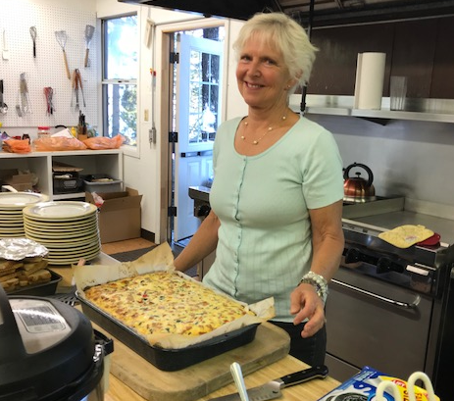
I cannot say how fortunate all of us were to have this experience available. It was not only rewarding to the blind and visually impaired hikers, but also the wonderful volunteers that are able to make this experience happen. It also would not happen without the tireless work that Vicky Post and Betsy Rowell put into making this event happen. They often noted that it isn’t perfect, but we learn something every year to make it better. I am so blessed to have this experience, and urge others to get out of their comfort zones by leaping into hiking and skiing with this group. It was fulfilling for my soul, my health and expanding my people I can
Karla serves a yummmmmy dish

call friends. I look forward to next year, and possibly skiing this coming winter-- counting down to only five months away. It’s cross country, too. I'd better get back to my workout.
MY FIRST SRSFL HIKING RETREAT
By
Jen Cook, VIP Hiker, San Francisco, CA
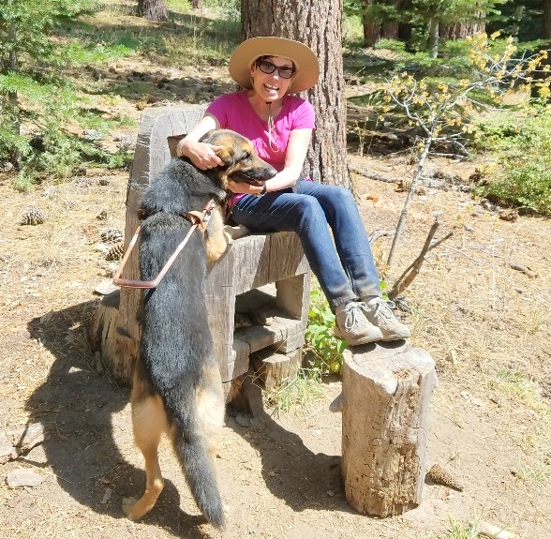
I first heard of the SRSFL hiking weekend several years ago. I was very interested but I couldn’t take time away from school. Hiking was once a regular part of my life, a favorite part of my life actually, but life changes over the last decade and a move to San Francisco had eliminated my hiking opportunities. Three years ago I was paired with my fifth guide dog, Iris, and I had somewhat accepted that ours might be the first partnership that wouldn’t involve hiking.

Just weeks before the
weekend retreat in August
Jen and her guide dog, Iris

things fell into place and I learned I would be able to attend my first SRSFL hiking weekend. I assure you it won’t be my last! The weekend was simply magical on so many levels – the camaraderie, being out in nature, the commonalities and differences amongst those gathered and the conversations that inspired, the food &, of course, the hiking!

On Saturday, the first day of hiking, I chose the Spooner Lake trail. I felt the simpler hike would allow me to adjust to the altitude, as well as check out how Iris and I were as hiking partners. She’s an incredible city dog but would we find our rhythm hiking together? The Spooner Lake trail is wide and it allowed us to discover what worked, pace-wise and what Iris felt necessary to “show me” or simply guide around. I was pleased to learn that Iris was quite adept at finding her stride out in the beautiful outdoors. Corrie was our sighted guide and the three of us worked together beautifully.

Feeling adjusted to the elevation and trusting my partnership, I unpacked my cane which I had brought along the day before “just in case”, we took on the Marlette Lake trail on Sunday. The trail was much more challenging with a steady climb, switchbacks, and a narrow, rocky trail with a drop to the right. We definitely found our rhythm and our heart’s delight on the Marlette trail! It has been many years since I have felt such peace and joy! I didn’t think my partnership with Iris could grow any deeper but, living in the City, I had no idea I had such a great little hiker at my side!

The weekend was beyond what I’d hoped for. It was lovely to begin every morning out on the deck, hearing the water and birds … with a cup of coffee, no less, already prepared by the volunteers! Speaking of the generous, wonderful volunteers brings me to Cyndy and Karla who nourished us with unbelievably delicious, nutritious meals. Truly, unbelievable – I felt wonderfully spoiled for three days! And, I loved that the Task List provided opportunities for the hikers to give back and participate in the whole experience. My time in the kitchen wasn’t only enjoyable, I was lucky enough to garner Karla’s secret ingredient for fruit salad…I’ll definitely be signing up for more kitchen work next time!

This weekend aged me in the most beautiful way … unfortunately, I forgot to pack my moisturizer but I’m certain smiling non-stop for three days has gifted me with some wonderful smile lines as well as the great memories! I was amazed by experiencing so many details and efforts falling into place to create an incredible weekend for everyone involved. Thank you so much to everyone – my fellow hikers, the well-loved volunteers, guides, and especially the Sierra Regional Ski for Light program for making all of this possible.

A REWARDING EXPERIENCE
By
Emily and Dan Patrick Guides, Nevada City, CA

It was a truly rewarding experience to spend some hiking miles with incredible non- sighted folks. We made friends that will be in our life forever. Can't wait until next year!!!

Thanks again for keeping us in the loop. We have not stopped talking about all of our experiences with all of our friends and family.
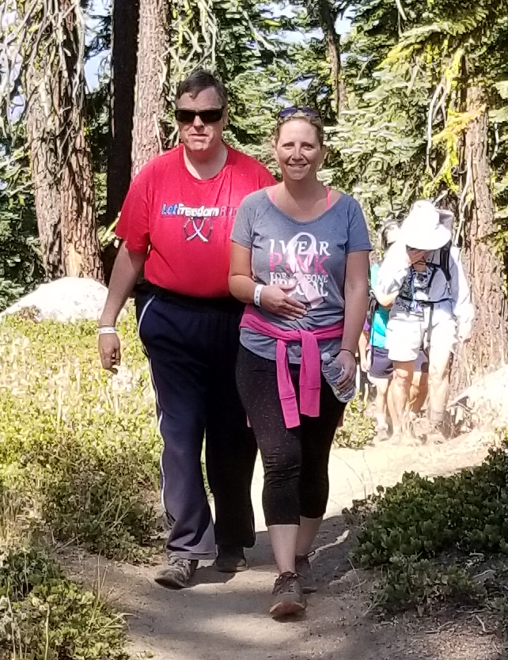
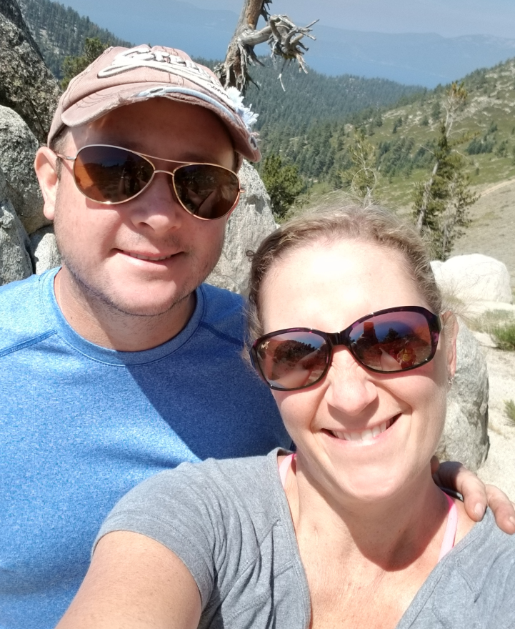
Frank and Emily on the trail Ne guides, Dan and Emily

LIGHTEN UP
By
Cathy Campbell, Guide, Citrus Heights, CA

After a few years of sharing pizza and conversation in the hotel on Friday night, I got hooked on the energy and enthusiasm of these VIP’s. I took the leap two years ago when I signed up to help with the hiking weekend. Learning how to become the eyes for an assortment of interesting and unique people became my pursuit.

In August, 2016, I drove a couple of VIP’s to a rustic lodge on the banks of beautiful Lake Tahoe for a hiking weekend. We sighted folks learned how to be guides, and I felt nervous about the responsibilities. I gradually became more comfortable, as I got to know people. I realized that, even if I did mess up, these folks had keen survival instincts, some like radar. Also, they weren’t going to hit me with their sticks if I was less than perfect.

We just returned from another rollicking weekend of adventures (and misadventures, e.g. yellow jackets). In the interest of brevity (and laziness) I won’t go into detail. Some highlights were bonding in a variety of situations: the car, the boat, kitchen, dorm room, trails, around the long dining table; and learning to ease up on myself, when I made mistakes. I didn’t get reprimanded even once.

When I think of the whirlwind of personalities and activities, the two most essential skills for me were observation and communication. The weekend provided me with the optimal opportunity to practice mindfulness, which has been a lifelong goal. I had to keep remembering that I am their eyes. I found myself noticing more obstacles and potential hazards. Learning how to clearly express verbal directions is ongoing. Vicki’s training, and observing other guides has been most beneficial. I’ve become more confident about speaking up, offering help. For example— assisting people in the buffet line.
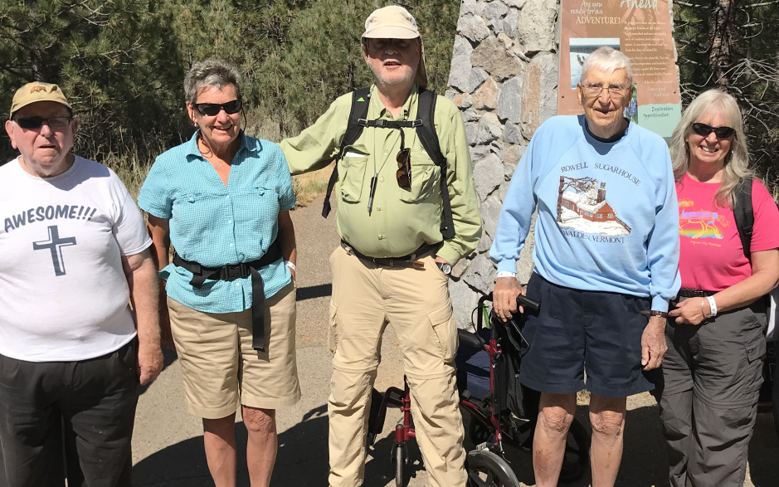
I feel very lucky to have found such a remarkable group of people to have fun with, while helping. I have benefited in more ways than brevity allows to express. For example, after I proudly cleaned a cookie sheet, it took a blind person to gently point out that it was not clean. By feeling, I realized it was still greasy.
Bill, AJ, Jon, Monte and Cyndy enjoy the walk at Taylor Creek

I highly recommend involvement with Sierra Regional Ski for Light for any sighted person who wants to be of service and laugh a lot!
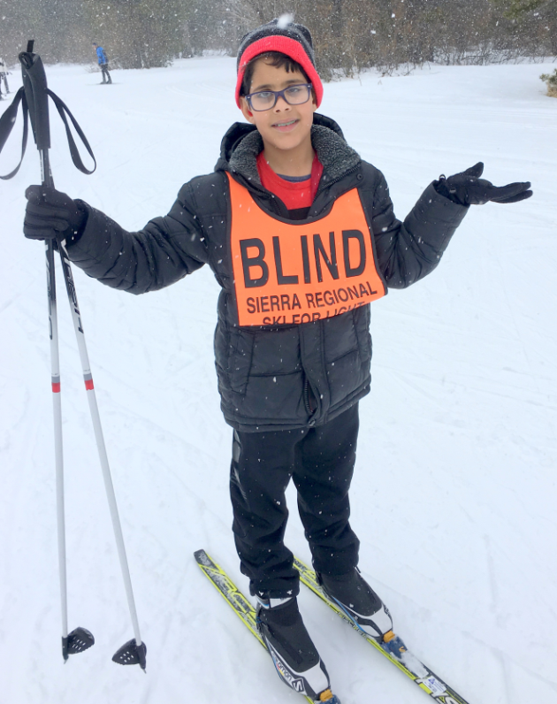
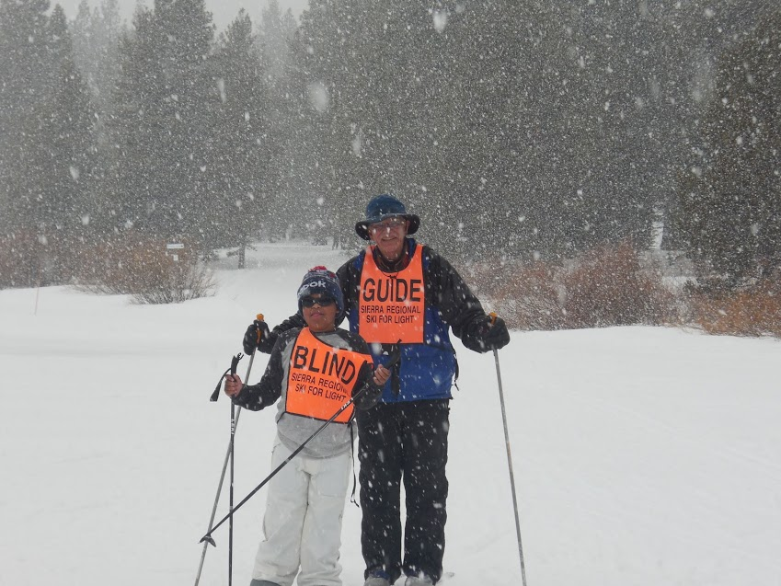
NOW ON TO WINTER

Mohammed, a happy skier
A fun day in the snow, Miles and guide Denny

EXCEPTIONALLY FUN & JOYFUL
By
Jean Snuggs, Sacramento, CA

I was unable to guide during the 2016-2017 season because of a number of conflicts; and I must say I missed the experience. So, this January I volunteered for the International Ski for Light group when they were at Tahoe Donner. That was a wonderful week for which I was well prepared from my past years of guiding for the SRSFL.

This year, I got to guide with the SRSFL on two separate weekends. Both times I guided an enthusiastic junior high novice skier, Mohammed. I must share with you that we had a great time – we skied, we talked, laughed, we skied, we had a snowball fight, we made a snowman, we skied some more, we worked on down hills -- and it was wonderful.

On the first day, as you all know, it takes some time to have a novice skier earn your trust as a guide and to settle on how best to communicate. But, after a short break, which included building a snowman and my teaching Mohammed how properly to make a snowball (which resulted in a good snowball fight), he really went to work and got into running on the skis and enjoying the glide. The highlight both days was to have Mohammed ski down the practice hill, without falling, several times. I was able to video his downhill and have replayed it many times; each time I watch, it makes me smile. It was a truly joyful experience. Thank you to Mohammed

THE EVOLUTION OF
SIERRA REGIONAL SKI FOR LIGHT
By
Monte Rowell, Sacramento, CA

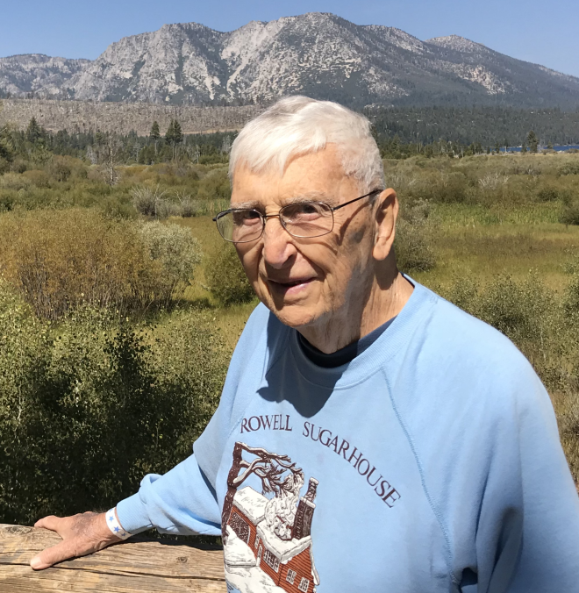
It all started around 1955 in a train station in Norway when Olaf Pederson and Erling Stordahl struck up a conversation about cross-country skiing, a very popular pastime in Norway. Erling, who was blind, lamented that blind people have a tough time getting around on skis, and asked Olaf if he could help with getting together a group of sighted folks that would ski with blind folks and help them out. So he did just that, and formed a group which later became known as the Ridderrenet (knights race). To say that the concept caught on is a giant understatement. Today it is a week long annual event in Norway. It is attended by about a thousand skiers, guides, volunteers and helpers from many countries. It serves not only the blind but also many other disabilities. There are ski races, both alpine and nordic. There is a biathlon competition in which blind skiers aim the rifles by sound. The Norwegian army participates, as well as the Norwegian royalty. You may find yourself skiing next to the king of Norway. Virtually everyone in Norway knows about the Ridderrenet.
When Olaf came to Breckinridge, Colorado, in the mid seventies, he started a program using the same basic concept, which he called Race For Light, now known as Ski For Light. It is a weeklong event held yearly at a U.S. ski area. Many of us have attended it. Since for many it was not convenient to travel very far to ski, there sprang up about 9 regional groups throughout the country. Today there are even regionals in Canada and Japan. Each regional group is autonomous, having its own by-laws, officers and treasury.

In 1993, coming back by train from Ski for light in Colorado, Betsy and I, along with Pat and Bob Slauson, decided that California, too, needed a regional. So we set about to organize Sierra Regional Ski For Light. It was rough going at first, and the first event almost didn't make it. Some wanted to throw up their hands and give up on it-too much hassle. But others persevered and said we should forget the organization part and just go up as a group of friends. So 7 guides and 7 skiers went to Tahoe Donner and had a ball.

An incredible amount of hard work followed, such as getting certified under 501(c)(3) of the IRS code, incorporating, generating forms, writing by-laws and a guide training manual. Finally we had a well-oiled machine that made a lot of people happy.

In 1994, Betsy and I again went to Ski For Light in Granby, Colorado. That year SFL rewarded one skier and one guide for outstanding work by sending them to the Ridderrennet. Betsy got to go due to her success in starting SRSFL. I also went as a tag-along. Betsy entered the 20 K race and won in her division. I attended the guide training, which was held in a large auditorium. When I returned and Betsy asked how it went, I noted that it was given entirely in Norwegian.
For the past 6 years SRSFL has had a summer event as well as the winter one. This has proven to be very popular. In August 2018 we had a successful one with 38 participants. We are in our 27th season now, and we look forward to many more.
THE SRSFL BOARD OF DIRECTORS
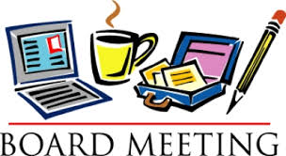
By
Vicki Post

SRSFL is governed and managed by a Board of Directors, elected by all SRSFL members. Every two years, half of the Board comes up for re-election. As of last May, we have a newly-constituted Board of Directors who will guide and maintain SRSFL for the next two years.

First, I would like to thank outgoing members, Toni Moore and Betsy Rowell, for their service to SRSFL, and I welcome their continued participation with us as non-Board members.

I would also like to welcome our two new members, Edie Lott and Shawna Ramsey. Congratulations, and I look forward to working with both of you.

PRESIDENT: Vicki Post
E-mail: VickiPost@earthlink.net

VICE PRESIDENT: Edie Lott
E-mail: thelotts@gmail.com

SECRETARY: Sue Mangis
E-mail: susanmangis@comcast.net

Treasurer: Cindy Quintana
E-mail: CindyQ12345@sbcglobal.net

MEMBER-AT-LARGE: Tom Gorin
E-mail: tdssg@gmail.com

MEMBER-AT-LARGE : Shawna Ramsey
E-mail: shawna2020@mail.com

And remember that all meetings are open to the public, so I welcome all of you who wish to participate with us. If you want to be notified of meeting dates, p/lease make sure you are on our email list. If you cannot attend, you may also listen to the minutes at a later date. Contact me and I will send you the playback instructions. Phone: 415-928-2711 or E-mail: vickipost@earthlink.net We are in our 27th season, and we look forward to many more.

FUND RAISING

Fundraising goes on year round. Fundraising may seem like a bit of a mystery to many of us, but it is one of the most vital elements to ensure SRSFL's bright future. Now that summer activities have been added to the program, extra funds are more critical then ever! So, anything you can do to help will be greatly appreciated. We are seeking supporters, donors, grants and cash. All money raised goes directly into the program for transportation,, scholarships and other expenses, and to keep the cost down for all.
Signing up for Amazon Smile is another way for SRSFL to raise money. Go to Amazon and choose SRSFL as your charity.

If you have questions, ideas and/or suggestions please contact Betsy Rowell, chair of the fund-raising committee. Phone: (916) 362-5557, Email: betsy.rowell2@gmail.com

SRSFL would like to take this opportunity to thank the many organizations and businesses for their support of our cross-country ski program and summer outings.

Please let them know how much you appreciate their support by patronizing their businesses and supporting their other activities.
Active 20/30 Club No. 1 of Sacramento
Adam's Vending, Gold River, CA
Auburn Host Lions Club, Auburn, CA
Commerce Printing, Sacramento, CA
Embarcadero Lions, Sacramento, CA
Folsom Lake Lions, Folsom, CA
Grant from the Peninsula Endowment (one time grant)
49er Ski Club, Sacramento, CA
Kiwanis Club of Citrus Heights, CA
Lions Education Foundation
North Tahoe Catering, Truckee, CA
Sacramento Turn Verein Actives
Sacramento Valley Sertoma Club
Safeway, Truckee, CA
Save Mart, Truckee, CA
Tahoe Donner X/C, Truckee, CA
The Treat Box Bakery, Truckee, CA

MANY THANKS also to the individual donors who have supported SRSFL throughout the years and the past year.

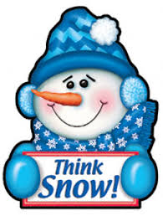
2018 - 2019 SRSFL CALENDAR

SKI GUIDE TRAINING

Date and time not yet scheduled, For guide training information contact:

Edie Lott
Home: 530 582-5362
E-mail: thelotts@gmail.com
or
Vicki Post
Home: 415 928-2711
E-mail: VickiPost@earthlink.net

SINGLE DAY SKI TRIPS

For Children and Adults

Saturday, January 25, 2019
Saturday, February 9 2019
Saturday, March 30, 2019

27th ANNUAL 3-DAY EVENT

March 9 - 11, 2019 ski weekend at Tahoe Donner Cross Country, Truckee, CA

Contact: Betsy Rowell
Phone: 916 362-5557
E-mail: betsy.rowell2@gmail.com
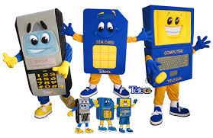
KEEP IN TOUCH

SIERRA REGIONAL SKI FOR LIGHT
c/o Edie Lott
10435 Royal Crest
Truckee, CA 96161
Phone: 530 582-5362
E-mail: thelotts@gmail.com

We are on the web
www.srsfl.org

