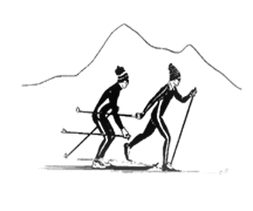
Sierra Regional Ski For Light
Newsletter
Summer 2017 Volume 13, Issue 1

WHO WE ARE
by
Betsy Rowell, Editor

Sierra Regional Ski For Light (SRSFL) is an all-volunteer, non-profit cross-country ski program for blind and visually impaired children and adults. Donations are tax-exempt under section (501)(c)(3) of the IRS code.

The program is a way for blind and visually impaired individuals to promote good health by being involved in a winter cross-country ski program and a summer program including hiking and water activities.

This newsletter is published annually, to provide information about the people and activities of SRSFL.

MESSAGE FROM THE PRESIDENT
by
Vicki Post
San Francisco, CA

Happy spring and summer to each of you. And whatever the season as you read this, may it be filled with great relationships and good outdoor fun!

Congratulations to SRSFL for the 2017 ski season. After four years of drought, we almost had too much snow. It led to

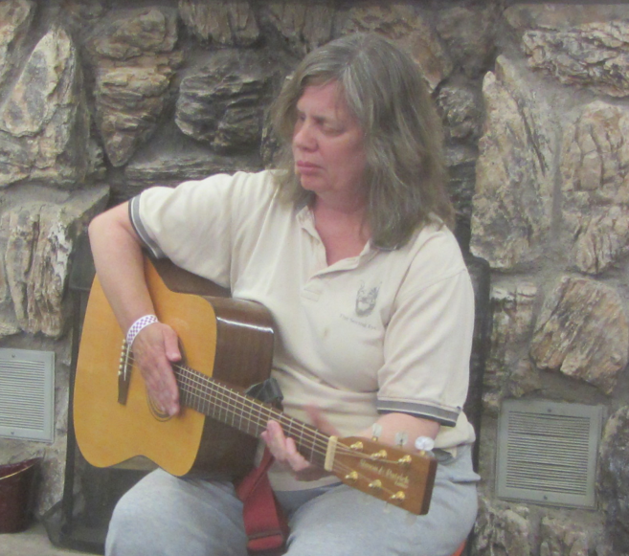
Preside Vicki Post

the cancelation of two day trips, but it made for some fabulous skiing and snowshoeing at our three-day event and final day trip.

This year, SRSFL celebrated its 25th anniversary, a real milestone in the life of any organization. We have grown in so many ways over the last 25 years, and yet, our basic mission, philosophy and overall spirit remain the same. Thanks so much to all those who helped make these past 25 year so successful.

As most of you know, SRSFL is an all-volunteer organization governed by a Board of Directors, which is elected from among its members. Each year, three of the Board positions come up for election. This year's election results were as follows: Vicki Post, President (elected for a second term), Treasurer: Cindy Quintana (elected for a second term), Board member-at-large I: Tom Gorin.
Thank you so much to all who participated in this election. Whether you ran for office, worked on the nominating committee, campaigned for someone, or voted, you helped set the course for the future of SRSFL, and your voice truly matters, even if your candidate did not win.

I would also like to thank outgoing Board member, Sylvia Reese, for her outstanding work as a Board member; and we look forward to her continued contributions to the life and growth of SRSFL.

One of the highlights from the 2017 ski season is the number of new relationships that were formed. If you have read any of my previous messages, you will know that I am all about partnership, and that is what makes SRSFL work. So, as we begin this next year, I encourage each one of you to develop and strengthen your connections with SRSFL, and we hope you will continue to partner with us for years to come.

For my part, I will do all that I can to maintain our popular summer hiking weekend, and to ensure that visually impaired people of all ages can cross- country ski and snowshoe during the winter. In the articles that follow, you will clearly see why so many of us come back and work year after year to make this possible.

Currently, SRSFL is in need of drivers who can drive from Sacramento to the mountains. In the winter, it is especially helpful if drivers have a car with all-wheel drive. We have a great bus for the three-day event, but have found it impractical to do this for our day trips. If you can help with this, please contact our transportation coordinator, Betsy Rowell:
Phone: (916) 362-5557 Email: betsy.rowell2@gmail.com. and remember, it is not too soon to start recruiting new visually impaired skiers!

Thank you again for being a part of Sierra Regional Ski For Light. Enjoy the newsletter, and I look forward to seeing many of you in the mountains.

MY FIRST EXPERIENCE
SKIING WITH SRSFL
by
Maureen Shultz
Berkeley, CA
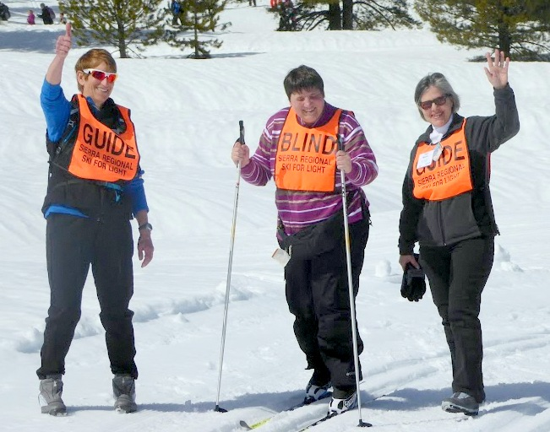
Maureen in the middle with guides
Estelle and Toni

I saw this e-mail, on the Berkeley Disabled list, and I’d heard about the organization before, this time the thought kept coming back. Why not? You’ve always wanted to know what skiing feels like. Come on just make that phone call…to Cindy, one of the coordinators…

Hum, hi, I’ve been thinking about coming… Should I? Could I? I mean, I’m not really into sports. What do I need to bring? Is it hard??? She was there. She was fun to talk to. Message: Don’t worry. Come on, try it…
Equipment? All available in the lodge. Clothes: I did a bit of looking around, and rented special ski pants—yes you can do that—for the weekend. Took the train to Sacramento, was met at the station. And that’s how it started.

Now you got blind people from all walks of life, some from out of State, like Utah or Oregon. You’ve got many that have skied for ever, you’ve got some beginners, and some never evers, like me. You’ve got totals, you’ve got partials, and you’ve got lots of sighted volunteers that are very well organized to provide definitely enough, but also not too much, assistance. You’re with the group, all day long, you’re also on your own, if you want or need.

The skiing itself, oh my God: first the air up there, the brightness of the sun, noticeable even for someone with only very little light perception. We were lucky that weekend, incredibly nice weather. I had two guides, one very experienced, Toni, and one in training
Estelle, both very competent in working with the blind.. I tried it, for two hours. It’s about gliding. It’s about sliding. It’s about laughing a lot. And if you lead too much from the mind, you make friends with your behind. And then—uhm—yes, you do get back up again. Lots of laughter, lots of support.

And then I tried the snow shoeing, and ended up staying with that for the rest of the trip, including an 8.6 kilometer walk on Monday before we went home, with my guide Estelle.

We had some very nice catered meals and a pizza dinner the first night. We celebrated SKI FOR LIGHT’s 25th anniversary, and we hope this local affiliate will keep going for a long, long time. But for that it needs participants: beginners like me, but really every level of experience is wanted and welcome. I hope to bring my sweetie next year. And thanks to everybody there, especially to my guides, and to that wonderful bus driver who kept us all coming and going and made sure we got there. I will never forget this trip, and hope to see some or all of the group as well as my wonderful guides again in the years to come.

2017 A GOOD YEAR FOR
GUIDE TRAINING
by
Edie Lott
Truckee, CA
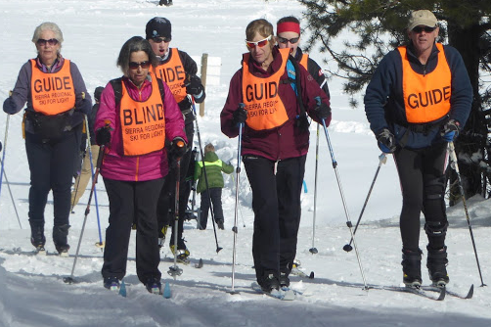
Guide training

This was a very good year for Guide Training. We added 3 members of the Bronstone family. Father Howard and son Aaron and daughter Grace, all expert skiers who show promise of becoming great guides! We also added Estelle Gray, a special education teacher with a bubbly personality and an intense desire to make a difference! A successful Guide Training is one of the great rewards that come with being Guide Coordinator. I think we have a great crop of new guides. It never ceases to amaze me that I always get much more out of Ski For Light than I put into it, whether it’s training new guides or guiding a blind skier. Looking forward to a great 2018 ski season..

NO EXPECTATIONS
NO DISAPPOINTMENTS
by
Estelle Gray
Sacramento, CA
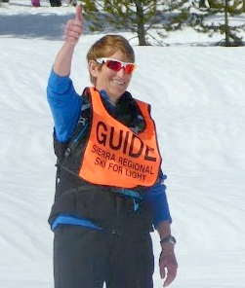
Estelle is a happy guide

That was my thinking when I signed up to guide with SRSFL. I had no idea what I was getting into and I ended up with a weekend to remember. After the first 15
minutes on the snow my skier was hating it, wanting to turn back and wondering why she came. By the end of Monday, not only did she promise to
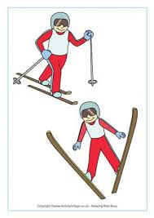

Become a ski guide

come back but was talking about bringing her boyfriend as well. We skied, we snowshoed, we went up hill, we went downhill, we fell, we got up, we fell again, we laughed, we encouraged each other, we shared stories. We'll both be back next year!!

MY LAKE THAOE ADVENTURE
BY
Robert Rayas
Los Angles, CA
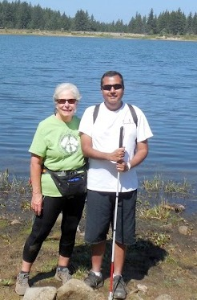
Robert and guide Edie at Spooner Lake

First thing I wanted to mention is that I was really kind of nervous about going as I really didn’t know anyone and my roommate who was the only person I knew was not going to make it after all. I am going to a place I have never been to and meeting a bunch of strangers. As a visually impaired as well as a sighted person it can be a little scary. But I felt comfortable as soon as I started meeting all the members and finding them very friendly.

The trip from Sacramento to Lake Tahoe was quick and it didn’t take that long. I went with 2 very nice ladies, one I had only met once and the other I had not met before. But it was a very enjoyable ride as the driver described all that was around us. really am an outdoor person and the smells of the pine and wood really smells so good to me. The air felt so fresh and clean my lungs were wondering what the heck was going on.

I had my own room in an older rooming type house which was great better than a hotel, with our own cook who made some great meals. As I got familiar with my surroundings I went for a little walk down to the lake which was a challenge as it was further than expected.

The next day was to begin the first of my hiking. My guide Edie was really great, she described everything around me: all the flowers, plants and the lake called Spooner Lake. It was very beautiful as she described it to me. We took a long nature walk which is what I wanted, to be able to soak in the area. We took some great pictures which I showed my family. Edie was a really great, guide and very a nice lady.

I went back to the lodge to get ready to take a boat ride. Now this was the highlight of my trip! It was so awesome to be able to drive the boat. Jim was so cool, he let me sit in the captains chair and let me steer the boat. We went fast and everyone in the back of the boat got wet. It was so exciting to be able to do something I have never done before, make turns in a high speed and put the pedal on the metal!. He described the different areas of the lake with all the expensive homes and houseboats. I never knew there were so many different areas of Lake Tahoe.

Now this was my first time to Lake Tahoe. I was kind of being a tourist so the next day we went on a walking trip through some old cabins that are right next to the lake. They were owned by a man by the name of Mr. Polk who was from San Francisco. He made his money in the lumber business. He had his cabins all right near the lake in which were turned into museums so people can go through and look at all the different rooms in the cabins. There were different cabins for all his workers butlers, maids, gardeners etc. The visitors could take tours. Then we went to Taylor Creek where we went on a nature walk and it was near the lake and got into the water for a bit it was cold but fun.. So it was a really great time .

I am really looking forward to doing it again with lots more hiking!.

BACK ON THE SNOW
WITH SRSFL
by
Chris Foster
Sacramento, CA
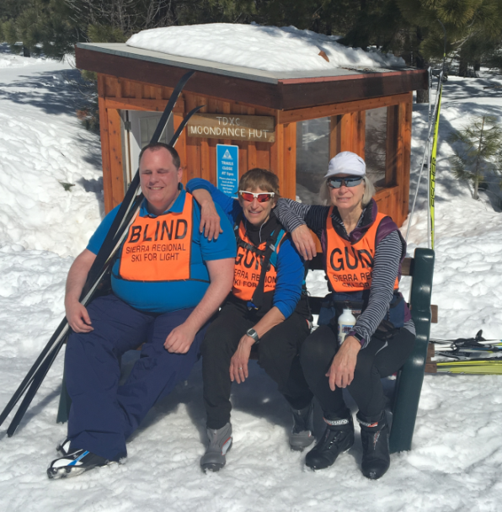
Chris with guides Estelle and Doris

Hi. My name is Chris Foster. I am a blind skier currently living in Sacramento, California.
I've had the opportunity to cross-country ski several times over the years and every time I've been out on the snow, I've thoroughly enjoyed it.

The last times I skied were at a Ski For Light International in Colorado in 2011
and then I was able to ski with the SFL Colorado crew in 2012.

Then, life happened. Over the next several years, I met with a number of life challenges including job changes, multiple cross country moves, and ongoing medical problems. I just wasn't able to make skiing happen.

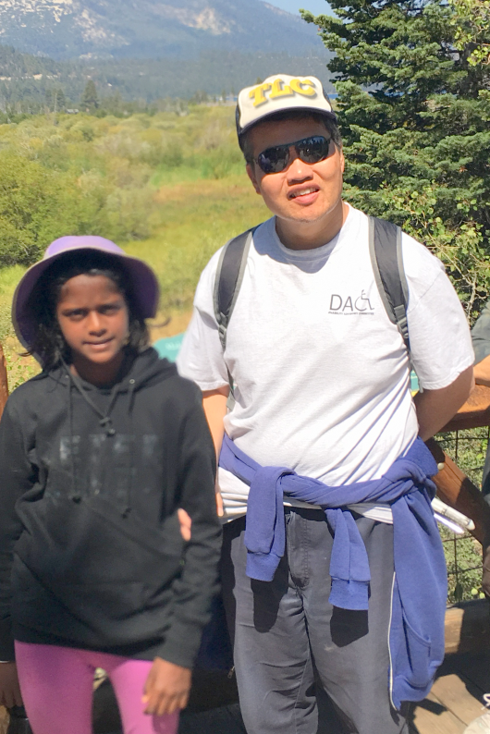
Then, early this year, I was walking out of my local Raley's when I met Sylvia Reese (a blind skier herself, as well as a very active member of the SRSFL board.) Sylvia told me all about the upcoming three-day event in March. It sounded interesting and so I kind of filed it away in the back of my head. A couple weeks later, I encountered Sylvia again, at the same Raley's. This time, she was really insistent that I consider going skiing. So, I wrote down the web site information and went home. Later that afternoon, I did some reading and finally decided I would apply to go on the trip. Betsy and Cindy with SRSFL helped me get through all the necessary money and paperwork hurtles and in a very short time, I was on the list.

At this point, I can't say how appreciative I am for the help SRSFL gave me by providing me a first-timer scholarship. The assistance made it much easier for me to attend.

The trip was wonderful Once I got familiar with skiing, I was up and moving. Being out there on the snow was fantastic. The more comfortable I got with skiing, the more fun and enjoyable it became. I also met a lot of really wonderful people while riding on the bus, sitting together at mealtimes, and other bits of downtime.

The people I met came from many different walks of life. There were teachers, students, social workers, retirees, and the list goes on. It became clear however, that all these people shared one commonality and that was a love for skiing and the desire to remove as many obstacles as possible to ensure that blind people could just get out there on the snow and enjoy themselves.

SRSFL is a wonderful organization and I am really glad that fate brought skiing and SRSFL back in to my life this last year. I thoroughly look forward to future activities with the people who make SRSFL the special group of people it has come to be.

GUIDEING FOR SRSFL
by
P J Lobo, age 13
San Francisco, CA
Guide P J and hiker Tommy

I recently went to Tahoe with SRSFL and helped guide visually impaired people ( VIP) on short hikes. In the past, I have also helped out with skiing.

From my experience, Ski For Light has been doing a great job of encouraging VIPs to get out of their comfort zone and go out and explore the world. Since these VIPs don’t have one of their crucial five senses, they need extra help. That’s what my dad sister and I did most of the day. When it was time to pack lunch all the VIPs would line up, and we would ask what they would like for lunch, and serve it to them in a baggy.

This experience was fun, and showed me a life lesson. The life lesson that I was taught, was that, you should always help another that has less of something that you have. It was also interesting to see how one lives their life without one of their crucial senses.

HELPING THE WORLD TO BE A BETTER PLACE
by
Maya Lobo, age 14
San Francisco, CA
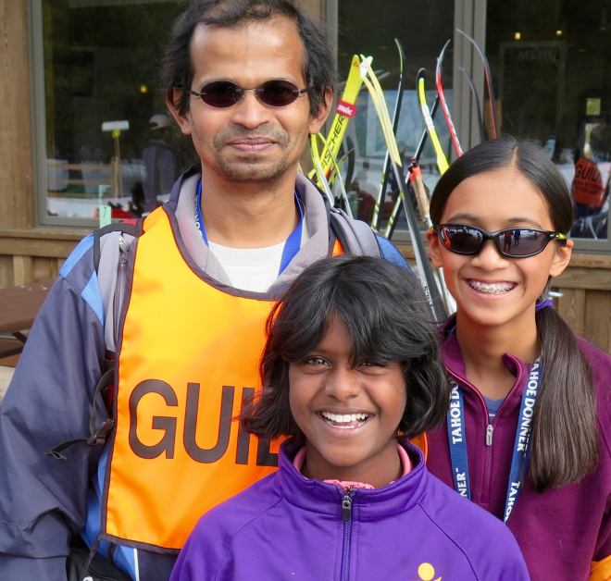
Dad Lobo with P J and Maya
My understanding of diversity has been built through travel, ethnicity, and volunteering. I have grown up in a country with diverse people from several socioeconomic backgrounds. My parents are Filipino and Indian. Every year we travel to India to visit family, and with each proceeding year, my perspective of this world has become more nuanced. I now look at the world with the idea that those who have more in life, are compelled to make the lives of others more equitable. For the past two years, I have gone to rural India to help out in schools, and improve the English reading and comprehension of students. I also spend quite a bit of time volunteering with a local organization, Sierra Regional Ski For Light, trying to help blind people get out of their comfort zone through hiking and cross-country skiing. Recently, I helped out with one program, and through doing so I got to learn how visually impaired people live their lives on a daily basis. Without sight, these people do not get to do a lot outside in nature. Volunteering with these organizations in India and around the Bay has given me a greater appreciation of the opportunities I have in life and my role in making this world a better place.

Last summer, my dad, sister and I went to South Lake Tahoe to volunteer with SRSFL. We guided VIPs on some short and long hikes.

During the short course of a couple days, I really learned a lot about how different types of people live their lives on a daily basis. Without sight, a crucial sense of the human body, these people don’t get to do a lot of things out in nature. And Sierra Regional Ski For Light is really allowing blind people to get outdoors. A majority of our time is spent hiking and riding a boat through the lake.
The boat ride was really fun and I along with the others had a blast driving it at full speed through the waters.

I had an amazing experience on this trip and hope to volunteer with this organization more often.
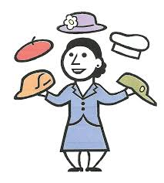
A SRSFL JUNIOR SKIER
GRADUATES FROM
SACRAMENTO STATE
by
Andi Thom
Sacramento, CA
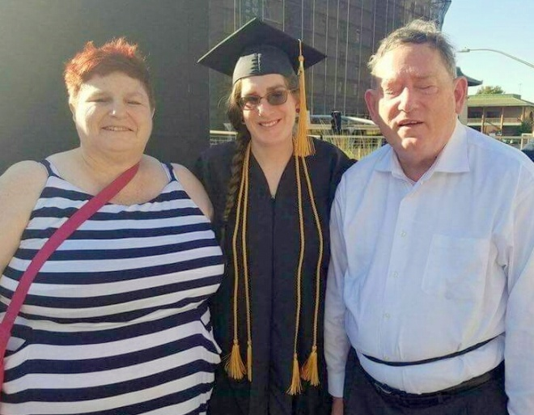
Andi and her proud parents,
Leslie and Jeff Thom

I have enjoyed skiing with SRSFL for more than a decade. The people I have met through SRSFL have greatly enriched my life. Now that my journey in Sacramento has come to an end, I'm headed to San Francisco State University to obtain a Masters in Special Education and become a teacher for blind and visually impaired children. I love being a part of the blind community and I would not change my vision for the world

FEATURED VOLUNTEER
Pam Bittner
A woman
of many hats

In an organization such as SRSFL, it is quite common for most of us to wear different hats, doing different jobs over the years. But few volunteers have worn as many hats as Pam Bittner!

Pam has been married to skier, Mike Bittner, for almost 12 years, and has been volunteering for SRSFL ever since she met him. And over these many years, Pam has made herself just about indispensible to SRSFL, and has made a real difference in the lives of many visually impaired skiers.

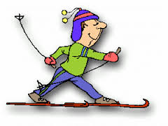
The first hat -- DRIVER! Year after year, she has driven her husband, his dog and countless others up to the mountains and back. And to SRSFL, drivers are worth their weight in gold!

The second hat -- DOGGIE DAY CARE! Many visually impaired skiers use guide dogs, but they are not allowed out on the tracks. So, while the handlers were out skiing and snowshoeing, Pam and her crew of volunteers took care of the dogs.

This means hanging with them in the hotel, walking each dog, communicating with each handler to report on the day, keeping track of leashes and the needs of various dogs, and trying not to slip on ice when out with the dogs.

No one has been more dedicated to the dogs' welfare than Pam, and all the dogs seem to agree. It's true; SRSFL has its own private "dog whisperer."

The third hat -- CHEF IN RESIDENCE! For the past two summers, Pam has generously taken on the role of chef for our hiking weekend. This allowed us to lodge and eat together under one roof, and do so rather efficiently. The menu was generous and yummy, and kept us all going strong through the weekend. Anyone who has ever organized food for an event will know how much work goes into the planning, shopping, cooking and cleaning. And it's no small feat to stay somewhat organized in the midst of the chaos of 28 to 30 people. And each day, she announced, the menu with such enthusiasm; it wet the appetite just to hear that cheerful voice.

The fourth hat -- WHATEVER ELSE NEEDED TO BE DONE! Pam is always ready to lend a helping hand where needed, directing someone to their destination, stepping in as a snowshoe guide, helping folks get food at the lodge, and engaging in some wonderful conversation at the drop of a hat!

Outside SRSFL, Pam displays the same variety of skills. She has worked in nursing, home health care, making truffles and more. She has faced the ups and downs of life with courage, and is incredibly devoted to those she loves.

From all of us in SRSFL, we say hats off to you, Pam Bittner, for years of dedication and hard work. Thank you for who you are, and for all that you have contributed to SRSFL. We are a better organization because of you!

FUND RAISING
Fundraising goes on year round. Fundraising may seem like a bit of a mystery to many of us, but it is one of the most vital elements to ensure SRSFL's bright future. Now that summer activities have been added to the program, extra funds are more critical then ever! So, anything you can do to help will be greatly appreciated. We are seeking supporters, donors, grants and cash. All money raised goes directly into the program for transportation,, scholarships and other expenses, and to keep the cost down for all.

Signing up for Amazon Smile is another way for SRSFL to raise money. Go to Amazon and choose SRSFL as your charity.
If you have questions, ideas and/or suggestions please contact Betsy Rowell, chair of the fund-raising committee. Phone: (916) 362-5557, Email: betsy.rowell2@gmail.com

SRSFL would like to take this opportunity to thank the many organizations and businesses for their support of our cross-country ski program and summer outings.

Please let them know how much you appreciate their support by patronizing their businesses and supporting their other activities.

Active 20/30 Club No. 1 of Sacramento
Adam's Vending, Gold River, CA
Auburn Host Lions Club, Auburn, CA
Commerce Printing, Sacramento, CA
Embarcadero Lions, Sacramento, CA
Folsom Lake Lions, Folsom, CA
49er Ski Club, Sacramento, CA
Kiwanis Club of Citrus Heights, CA
Lions Education Foundation
North Tahoe Catering, Truckee, CA
Sacramento Turn Verein Actives
Sacramento Valley Sertoma Club
Safeway, Truckee, CA
Save Mart, Truckee, CA
Tahoe Donner X/C, Truckee, CA
The Treat Box Bakery, Truckee, CA

MANY THANKS also to the individual donors who have supported SRSFL throughout the years and the past year.

2017 - 2018 SRSFL CALENDAR

HIKING WEEKEND

August 25 - 28, 2017

We will once again be returning to Zephyr Point Conference Center, Zephyr Cove NV. for a weekend of hiking and being together. For more information, contact:

Vicki Post
Home: 415 928-2711
E-mail: VickiPost@earthlink.net
or
Betsy Rowell
Home: 916 362-5557
E-mail: betsy.rowell2@gmail.com

SKI GUIDE TRAINING

Thursday, February 8, 2018
Evening guide training in Sacramento

Saturday, February 10, 2018
Evening guide training in Truckee

Sunday, February 11, 2018
On-the-snow training in Truckee

For guide training info. contact:

Edie Lott:
Home: 530 582-5362
E-mail thelotts@gmail.com
or
Vicki Post,: Guide
Home: 415 928-2711
E-mil VickiPost@earthlink.net
SINGLE DAY SKI TRIPS For Children & Adults

Saturday, February 10, 2018
Saturday, March 31, 2018

Contact: Betsy Rowell:
Phone: 916 362-5557
E-mail: betsy.rowell2@gmail.com
26th ANNUAL 3-DAY EVENT AT TD XC Truckee, CA

March 10 - 12, 2018 ski weekend at Tahoe Donner Cross Country, Truckee, CA

Contact: Betsy Rowell:
Phone: 916 362-5557
E-mail: betsy.rowell2@gmail.com

THE SRSFL BOARD OF DIRECTRS

The SRSFL membership elected one new board member (Tom Goren) this year. Thanks to the outgoing member (Sylvia Reese) for her service and her hard work for a successful candy sale this year.

PRESIDENT - Vicki Post
VickiPost@earthlink.net

VICE PRESIDENT - Betsy Rowell
betsy.rowell2@gmail.com

TREASURER - Cindy Quintana
CindyQ12345@sbcglobal.net

SECRETARY - Sue Mangis
susanmangis@comcast.net
Phone: (916) 638-4584

MEMBER AT LARGE 1 - Tom Goren
tdssg2@gmail.com

MEMBER AT LARGE 2 - Toni Moore
tonijmoore1@gmail.com

IMMEDIATE PAST PRESIDENT
David Hoffman
DavidHoffman1965@gmail.com

KEEP IN TOUCH

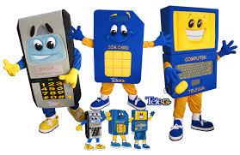

SIERRA REGIONAL SKI FOR LIGHT
c/o Edie Lott
10435 Royal Crest
Truckee, CA 96161 Securer
Phone: 530 582-5362
E-mail: thelotts@tlpc.org

WE'RE ON THE WEB
www.srsfl.org

