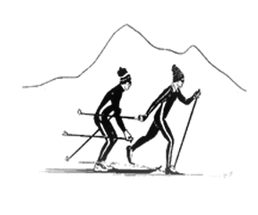
Sierra Regional Ski For Light
Newsletter
Summer 2016 Volume 12, Issue 1

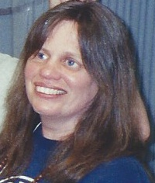
WHO WE ARE
by
Betsy Rowell, Editor

Sierra Regional Ski For Light (SRSFL) is an all volunteer, non-profit cross-country ski program for blind and visually impaired children and adults. Donations are tax-exempt under section (501)(c)(3) of the IRS code.

The program is a way for blind and visually impaired individuals to promote good health by being involved in a winter cross-country ski program and a summer program including hiking and water activities.

This newsletter is published annually, to provide information about the people and activities of SRSFL.

MESSAGE FROM THE PRESIDENT
by
Vicki Post
San Francisco, CA

Willkommen; bienvenue, welcome!
On behalf of Sierra Regional Ski for Light (SRSFL) I would like to thank each and every one of you for all the many ways you have participated with us this past year. Whether you skied, snowshoe, guided or volunteered in any capacity, you made a difference in
Vicki Post, President

someone's life and in the life of this organization.

First, I would like to acknowledge the three outgoing Board members (Pat Slauson, Vice President, Mike Bittner, secretary; and Betsy Rowell, member-at-large) for their hard work and dedication to SRSFL. Next, I would like to welcome our three new Board members, Betsy Rowell, Sue Mangis and Toni Moore; I look forward to working with you in the year to come, when we will be planning our 25th anniversary! How time flies!

I would like to thank the SRSFL Board of Directors, the skier and guide coordinators, fund-raisers and recruiters who have worked very hard to make this past ski season a reality and a success. Much like skiing itself, it takes some effort to gain the skills, try this and that and then finally, when you get it right, it's really pretty thrilling. So thank you to all of you; you are the heart and soul of SRSFL.

As for this year, may it be remembered as the year we finally had snow! Over the last few years, seasons, as they are called, have been a little unpredictable -- snow in September, people hiking in February and so on. This has trickled right down to our own ski seasons which have been anything but normal. But, as many of you know, neither drought nor storm nor traffic jam can dampen the SRSFL spirit of adventure, camaraderie, resourcefulness, caring, and taking a break when necessary.

As I write this, the 2016 ski season has come to a close and the sun is shining, but we did manage to hold one day trip, along with a great three-day event. May the snow fall at least as steadily next winter, and I will avoid broken limbs so that I can actually attend.

Thanks to some much-needed snow, we were able to train nine new guides this year, and I am very excited about that. We continue in our fund-raising efforts; we welcomed some new young people as skiers and guides, and our summer/fall weekend is turning into an annual event. Yes, there will be a summer weekend in 2016.

And if you have ever had the chance to feel the famous SRSFL glow, I invite you to experience it again, even when it isn't winter. As many of you know, the work of SRSFL continues year-round, so as you meet people, enjoy the out-of-doors and delight in all aspects of your life, give some thought to ways in which you might help us out. Feel free to talk to Board members, Committee chairs and anyone else about what they do; we would love to have your input, skill and energy to help keep SRSFL alive and thriving.

Many thanks go to all the Staff and Management of Tahoe/Donner for welcoming and accommodating us year after year. Our work is so much easier each year because we have a reliable venue, and I am very grateful for their ongoing support.

Finally, I would like to thank all the SRSFL donors and supporters who give quietly and behind the scenes so that we can enjoy whatever the mountain has to offer us.

Please come join us next winter as we celebrate 25 years of SRSFL magic. Meanwhile, I wish you all a wonderful summer and fall, and look forward to seeing you on the trails, both the ones we blaze and those we find in the mountains.

BECASUE OF SRSFL
by
Terry Kirby
Woodland CA
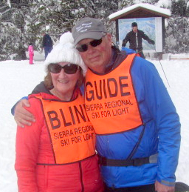
Bruce and Terry are off for a day of skiing

How does a 66 year old woman, who happens to be blind and has never had a pair of skis on, get talked into going skiing? Here’s how… a member from the Sierra Regional Ski for Light (Sylvia Reese) calls a friend Lucinda Talkington (who happens to be the founder of The Outa Sight Support Group located in my town.) She sends an email to me and to another member, Darrell Horst stating that the two of us really need to go on this trip from March 4 -7, 2016. And so the adventure begins.

I was so anxious to meet new people but in the back of my mind I was worried whether a totally blind person could really cross country ski. On March 4th SRSFL ordered in pizza for a meet and greet event and it became apparent that some of the other participants were totally blind and have been cross country skiing for years.

On March 5th we arrived at the Ski Lodge and I met, my first Guide, Matt, and a volunteer in training, a 9th grade student, Riley, who was shadowing Matt. Everything I did that day was a first for me, getting measured for boots, poles and skis. Not to mention putting the ski’s on for the first time. I was both excited and scared! My biggest fear was going down a hill, no matter how small -- I’m talking that a mole hill would scare me. So, after some instruction from Matt, which included “get in the Groucho Marx position” I began to slowly move on the snow. My
Terry gets a helping hand from Mat
first hour and half was on flat surface, in the Meadow, and I was a creeping crawler. I guess I would call this snail
skiing! After lunch I put my skis back on and headed for the safety of the flat meadow. All was going well; I actually glided for the first time. It excited me so much that I stopped to catch my breath. Exhilarating!!

This was a new feeling that I had never experienced before. Gliding instead of walking, what a new sensation. Then it happened, the hill (approximately 5” high and a 25 ft. glide), I was terrified! Matt was wonderful and we did this mountain, SMILE, in tandem. After the end of my glide I stopped and screamed with excitement; kind of like you act riding a roller coaster.

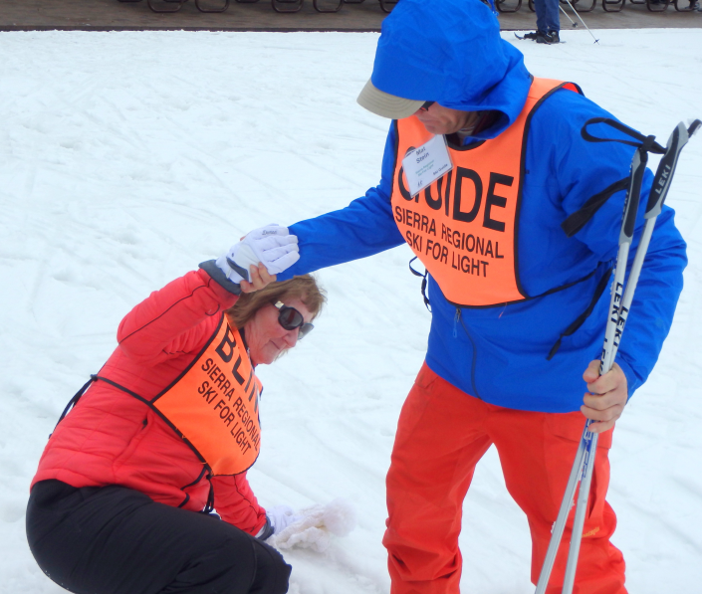
On March 6^{th,} I had decided that I would snow shoe that day – I was still scared of the hill even after being excited the day before. So I announced this decision to my new Guide, Bruce. His reply was “that’s not very challenging”. Next thing I knew I was putting ski’s back on. I expressed my fears and into the flat meadow we went. Looking back on this, I realize that he was subtly encouraging me to get in the athletic position, push off on the poles and glide a little more. For some reason, every time I would glide a little bit, I would stop to catch my breath because I would get so excited. So, Bruce said this time don’t stop gliding until I count to 10. I did it. Now, Bruce said don’t stop until I get to 15 and then 20. You get the picture. I became very interested in gliding longer and longer. Bruce’s continual encouragement gave me so much confidence that before I knew it I was gliding down my mole hills without any fear! At that moment I believed, with several more trips, that I could become a cross country skier. What a feeling of triumph.
March 7th, it was snowing, tracks were deeper and I was more relaxed. I was open to try anything at this time. I even raced Darrell back to the lodge. So I fell and he beat me into the lodge. However, I realized at that moment that I was a winner too – I conquered my fears. Lots more confidence and a desire to come back for other ski trips. I am in awe of all the volunteer guides that make this event such a success. The volunteers give up their own time to help blind and visually impaired people enjoy skiing. I felt the love and heard the joy in my guide’s voice as I improved and began to love this sport. How do I ever express how grateful I am to the Sierra Regional Ski for Light program? This organization is stuck with me for life!!! Yours truly,

A 5 STAR EXPERIENCE
by
Annalisa DiLeonardo
San Francisco, CA
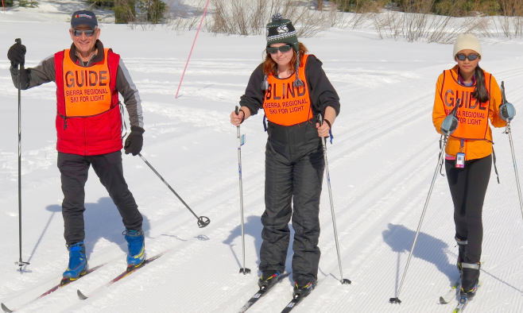
Skier Annalisa, guide Lynn and junior guide
in training Maya

I recently had the chance to go cross-country skiing for the first time last Saturday, and it was one of the top five experiences I ever had…I walked into the ski lodge with my guide dog Walton by my side. My eyes were open wide, as wide as they can go. I saw so many people carrying skis, a small sport gift shop and a restaurant. We where led to the clubroom, witch was an awesome place not only for Sierra Regional Ski For Light but families with children. The ski lodge had fabulous staff that were asking if we needed anything. We met people from Sierra Ski For Light and started learning who our guides were. We then went and got fitted for our skis, here was the start of my day full of fun. Once I met up with my guide, Lynn, and a guide in training, Maya. I was so excided when I heard the snap of my boot going into the ski. We started going over commands and how we were going to communicate on the trails. When I first started, I was nervous since I can't see well. I was worried about crashing. But, when I did my first trial I heard Lynn giving me so much audio description and telling me where to go, that all the nervousness left me. I was able to relax, enjoying skiing and the sights and sounds around me. I was free, free as my sighted friends. I went through so many trials with Lynn and Maya taking turns guiding me. The best and most magical part of my day was when I was able to go down a big hill. I felt so free and absolutely loved going fast. The part that made it most magical was I did not have to worry about crashing, since Lynn was always there
ready to give me directions. It was truly a magical experience and I am so thankful to Sierra Regional Ski For Light, and my guides Lynn and Maya. This program is truly amazing and I hope to join them in the future. Thank you to all from the bottom of my heart.

A WONDERFUL EXPERIENCE
by
Delanie Carpenter, 16
Carpenter, 16 Carmichael CA
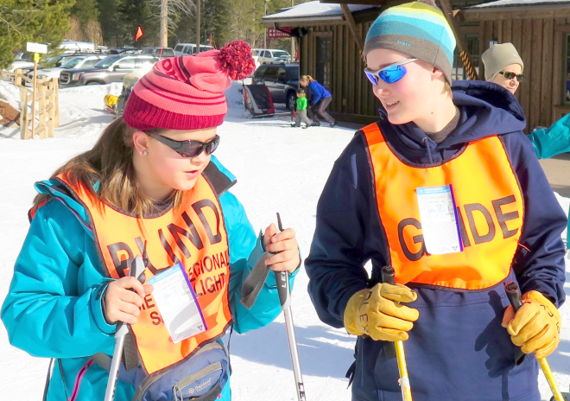
Delanie and junior guide Kati are ready to ski
I had a beautiful time skiing with Kin Fong and Katie Plexico. I accomplished my goal of not falling twice and I'm proud of myself. I think cross-country skiing is pretty awesome, I loved gliding fast and double poling, although I got tired of it. This was the first time I cross-country skied. I felt cool because I was trying something new. Thank you for the outstanding guides you gave me and the wonderful ski days you gave me. All of you are my heroes.

A VOLUNTEER OPPORTNITY
by
Riley Hacker, 15
Tahoma, CA
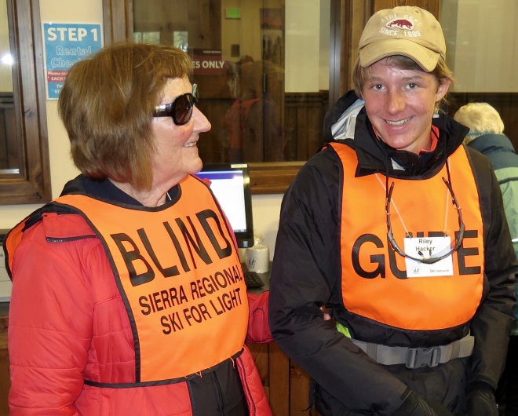
Terry chats with Riley

I am a freshman at North Tahoe High. I enjoy volunteering in my Community and I was looking for a new volunteer opportunity, when a friend of mine from school told me about the Sierra Regional Ski for Light program. I thought it would be a great fit for me because I am on the North Tahoe Nordic Ski Team and I could share my love for skiing with visually impaired people that might not otherwise get to experience Cross Country skiing.
Becoming a Ski for Light Guide began with several hours of classroom training where I learned the basics of guiding visually impaired people, or VIP’s around the building, before we even began to work on the art of guiding in the snow. To demonstrate this we blindfolded a partner and took turns guiding them around certain obstacles that we may encounter, so that we would be ready for the real thing. I found this interesting, because, before this experience I have never met, or talked to anyone with visual impairments, so I did not know what to expect. This was a whole new world, that I am glad I am now a part of. I was taught the basic terminology used to describe certain steps in skiing and what things I should go over when they first step off the bus, such as their health, skiing abilities, and other things to help me to get to know them. One the most important things that I did not even realize before I met this group is that visually impaired people are no different than I am. Just because I can see now does not mean that something will not happen later in life that will cause me to go blind myself.
After the classroom training, I had one more part of training to complete before I was on my way to show that I had what it takes to become a guide to the skiers. The next part of training would be on skis. When I got to the ski area, I had no idea what to expect yet again. I was greeted like I already belonged there, and as the day went on I was met with one new thing after another. One thing that I felt helped a lot was being blindfolded while skiing so that I could better understand what it might feel like for the visually impaired people I would be guiding. This helped me realize what things I liked and did not like so that when I guide, I can understand what their problems and thoughts might be. Later on when I was shadowing an experienced guide, I realized how important that was, because I could relate to the things that our skier was struggling with. After completing the guide training I am excited to be able to guide on my own next year.
One of the most rewarding things about guiding people is the fun and enjoyment they get from doing something that without this program, they may never get to do. I felt that this experience was fun and rewarding, and I plan to continue doing it for a long time.

Take a hike?
by
Vita Zavoli
San Leandro, CA
Vita kayaking on Lake Tahoe

Yes, it was my husband, Frank, and my friend, Judy, who graciously told me to "take a hike."

In August of 2015, I was fortunate to have the opportunity to take a four-day weekend to the beautiful wilderness of the Lake Tahoe area with the SRSFL team. What a weekend with great people, great volunteers, great cooking and great sports.

We had a lodge all to ourselves and at almost any time of the day, you could smell the preparation of breakfast or dinner. We had a nice large porch where we could eat, make new friends or simply enjoy the sun and breeze. I had to leave my window open at night so I could hear the call of the morning birds to wake me up bright and early and the soothing sounds of rustling leaves in the wind and the waves from the lake to loll me to sleep at night.

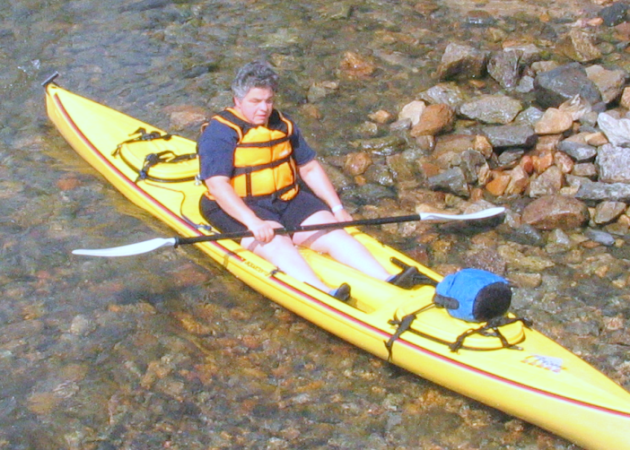
I participated in three of the shorter hikes that weekend. When I think of hikes, I think of a nice walk in the woods to the accompaniment of nature's sounds, smells and gentle brushes from leaves, flowers, bushes and trees. To add to the special bond I felt with nature while hiking this weekend, I also bonded with new people, guide dogs and way too much food!! Having a volunteer on a hike provides the bonus of having nature's beauty described, knowing when to bend down to touch something new and quickly maneuvering over rocks or logs. Oh, and knowing that you are almost at the top of the hill!

In addition to hiking, I went swimming in the pristine waters of Lake Tahoe several times, took a great boat ride on the lake with fun folks and got the t-shirt to prove it.

Our evenings were restful with talking, laughing and guitar playing. We shared a little bit of ourselves through our talents and stories. You just never knew what topic would arise when you sat down at the long, wooden table for the group meals.

Next time someone tells you to "take a hike," do it with SRSFL!

Would I go again? You betcha!!!
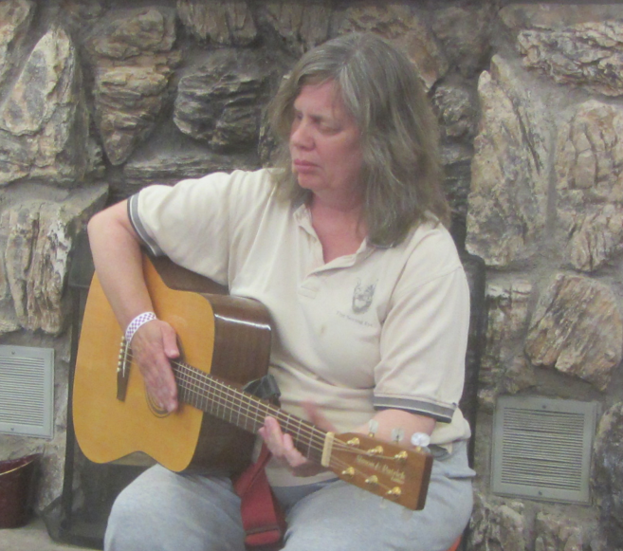
President, Vicki shares her love of music

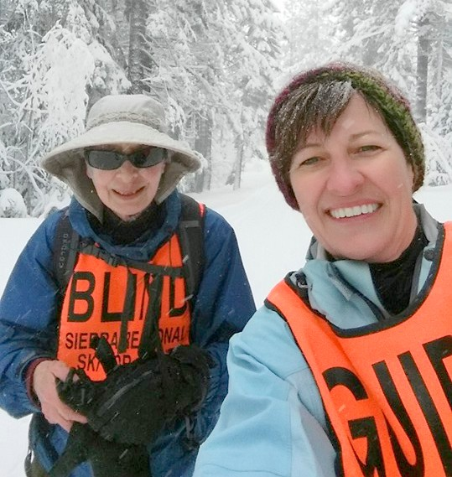
GOING FAST DOWN BIG HILL
by
Miles Lima, Age 7
Manteca , CA
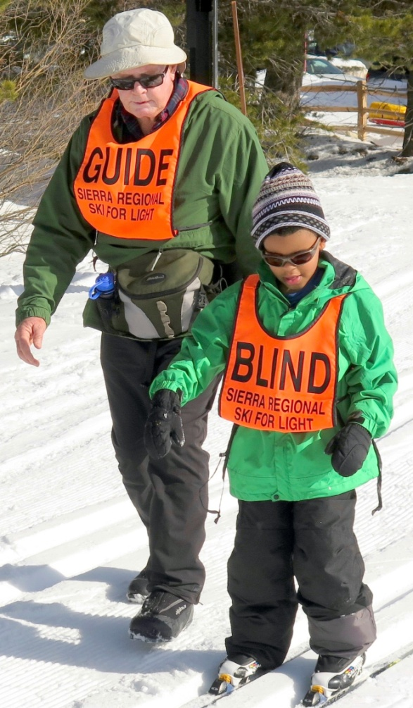
Miles first day on the snow with
guide Charley

I wanted to thank your organization for the opportunity to learn how to ski. My instructor Mr. Charlie and Mr. John were great and very helpful. One of the things I enjoyed most was going fast on the big hill. I'm looking forward to next year so I can bring my bring again and I hope to bring my brother and sister.

AN AMAZING EVENT
by
Katherine Black, Incline Village, CA

What an amazing 3 Day event, truly grateful to be part of a wonderful organization, Sierra Regional Ski for Light. I am
Marilyn and Katherine

continually in awe of the skiers who allow and trust us to guide them on x/c skis through some spectacular scenery. I have been guiding Marilyn for several years now, she is 77 years young, with about 15 to 20 percent of her vision remaining and she has the energy level of someone 20+ years younger. She is my inspiration! Thank you to everyone at SRSFL and especially Edie, our guide coordinator who keeps us all organized!
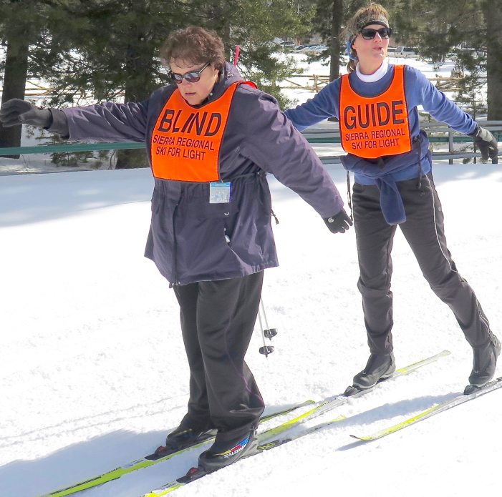
Skier Sylvia and guide Shawna practice skiing without poles.

A FABULOUS TIME
by
Margie Smith
Reno, NV

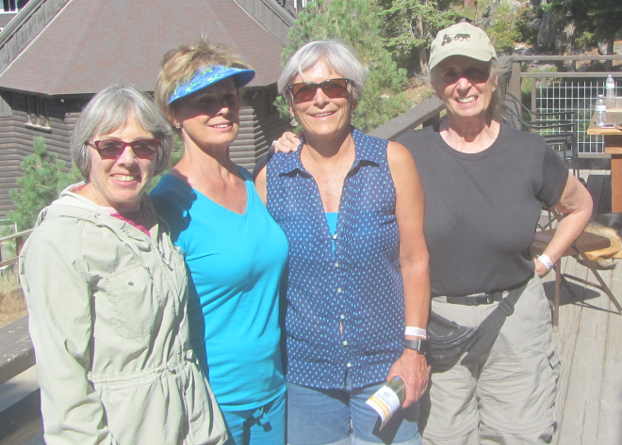
SUMMER GUIDES
Corrie, Margie, Judi and Cyndy

Hello to all!!! I had the best time with each one of you. It was a fabulous time and I learned so much and still can learn more. I was so impressed with the independence of you all, it gave me a sense of gratefulness and so much pleasure to be part of a great experience. Everyone was full of energy and very grateful for us as volunteers. It was my first time and I can’t explain all the different feelings I had. I would love to be involved again.

Pam, your wonderful helpers in the kitchen, was amazing and I would enjoy helping in the kitchen again. I am still talking and telling all my family and friends how wonderful it was and what a great opportunity it was to meet and share some fun. The beautiful outdoors of Lake Tahoe is amazing just as each and every one of you were. I’m not a winter girl so I hope to be invited back for the summer activities.

Miss all of you and take good care of yourselves. Looking forward to seeing you on another adventure.

A REWARDING EXPERIENCE
by
Cyndy Hutchinson
Nevada City, CA

This is my 2nd year of being a visual guide for SRSFL at Lake Tahoe. Working with SRSFL has been a very rewarding and fulfilling experience for me. Our activities this year included, hiking at various levels, swimming and boating ~ so much fun for everyone.

Through volunteering with SRSFL, I have met some of the most wonderful and interesting people who love and appreciate the out of doors just like me. Patience is crucial in organizing the various hikes with the utmost of safety being the biggest factor.

Everyone in the group appreciates the “team” spirit and approach to our hikes. Keeping this in mind, everyone is as safe as possible throughout all of our adventures.

See you next year.

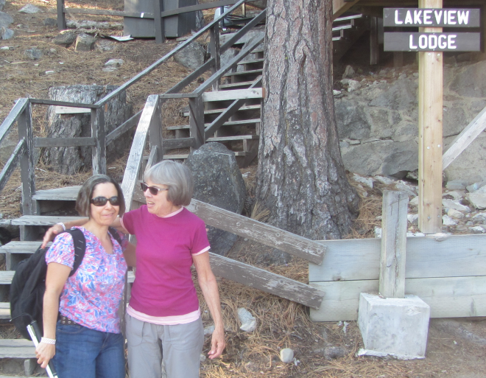
Cindy and guide Corrie are off for a hike

A GREAT SKIING EXPERIENCE
BY
Arash Dabestani
Lomas, CA
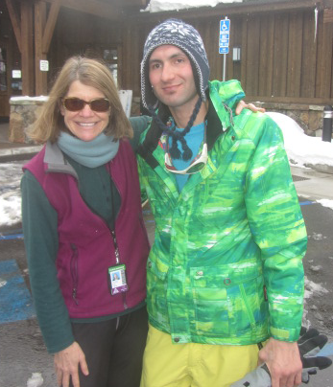
Arash and Mary after a day of skiing

Hi - It is Arash Dabestani, and I had a great skiing experience with Sierra Regional Ski for Light.

Before this event, if I heard a blind person can ski, I would be shocked. But now, it is completely acceptable for me.

This experience makes me believe I can do many things in my life and get more fun and energy.

Mary, my nice guide, explained everything to me. Mary used specific ways to teach and
Communicate with me; it was the reason I could understand completely. I truly appreciate her.

At first I was scared, but step by step I learned how to ski and it became easy for me.

In addition, I found some new friends, and I made very good relationship with them. As English is my second language, it was very good opportunity for me to improve my English. I am originally from Iran, and I have been in USA for 20 months. Much appreciation.

I HUNG UP MY SKIS AND SNOWSHOES
by
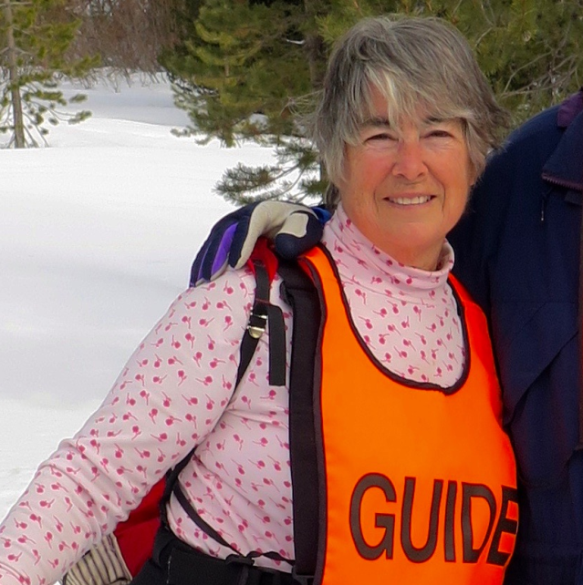
Susan Totels
Grass Valley, CA
Susan is a happy guide
Years ago, I was introduced to Cross Country skiing. I enjoyed the sport but found I had no one to go with! Several friends tried but didn't enjoy it as much as I did. Then I tried snowshoeing with the same results. I enjoyed it but no one wanted to join me. I realized neither of these sports should be done alone so for a while I hung up my skis and snowshoes. But, I was also a square and round dancer! One day I was talking with fellow dancers Ken and Zinnia and they mentioned Ski for Light and guiding the blind. Well I thought why not? I was trained at Betsy and Monte's house and really enjoyed the adventure and most of all the people. I guided one year and the next two years due to poor snow conditions didn't guide. However this year the snow was great and I once again was able to guide. I have never met a more positive group of people and look forward to many years of enjoying their company.

FUND RAISING

The 2016 SRSFL ski season has come to a close, BUT fundraising goes on year round. Fundraising may seem like a bit of a mystery to many of us, but it is one of the most vital elements to ensure SRSFL's bright future. And now that we are adding summer activities to the program, extra funds are more critical than ever! So, anything you can do to help will be greatly appreciated. We are seeking supporters, donors, grants and cash. All money raised goes directly into the program for transportation, scholarships and other expenses, and to keep the cost down for all.
Signing up for Amazon Smile is another way for SRSFL to raise money. Go to Amazon and choose SRSFL as your charity.
If you have questions, ideas and/or
contacts, please contact Betsy Rowell, chair of the fund-raising committee.
Phone: (916) 362-5557
Email: betsy.rowell2@gmail.com

SRSFL would like to take this opportunity to thank the many organizations and businesses for their support of our cross-country ski program and summer outings. Please let them know how much you appreciate their support by patronizing their businesses and supporting their other activities.

Active 20/30 Club No. 1 of Sacramento
Adam's Vending, Gold River, CA
Auburn Host Lions Club, Auburn, CA
Commerce Printing, Sacramento, CA
Embarcadero Lions, Sacramento, CA
Folsom Lake Lions, Folsom, CA
49er Ski Club, Sacramento, CA
Kiwanis Club of Citrus Heights, CA
Lions Education Foundation
North Tahoe Catering, Truckee, CA
Royal Gorge X/C, Soda Springs, CA
Sacramento Turn Verein Actives
Sacramento Valley Sertoma Club
Safeway, Truckee, CA
Save Mart, Truckee, CA
Tahoe Donner X/C, Truckee, CA
The Treat Box Bakery, Truckee, CA

MANY THANKS also to the individual donors who have supported SRSFL throughout the years and the past year.
2016 - 2017 SRSFL CALENDAR

HIKING WEEKEND

October 14 - 17, 2016 Hiking weekend at Zephyr Point Presbyterian Conference Center, Zephyr Cove, NV We will once again be returning to Zephyr Point for a weekend of hiking and being together. For more information, contact:

Contact: Vicki Post
Home: 415 928-2711
E-mail: VickiPost@earthlink.net
or
Betsy Rowell
Home: 916 362-5557
E-mail: betsy.rowell2@gmail.com

SKI GUIDE TRAINING
AND DAY TRIPS

The dates for guide training and the Saturday day trips have not been set. Check the SRSFL web page for dates @ www.srsfl.org.

For guide training contact,
Edie Lott: Guide Coordinator
Home: 530 582-5362
E-mail thelotts@gmail.com
or
Vicki Post,: Guide Training Coordinator
Home: 415 928-2711
E-mil VickiPost@earthlink.net
SKI TRIPS FOR
CHILDREN AND ADULTS
AT Tahoe Donner X/C
Truckee, CA

Contact Betsy Rowell:
Home: (916)362-5557
E-mail: betsy.rowell2@gmail.com

25th SRSFL ANNIVERSARY ANNUAL 3-DAY EVENT

March 11- 13, 2017
Tahoe Donner Cross Country,
Truckee, CA
Contact Cindy Quintana:
Phone:(510)483-2948
E-mail: CindyQ12345@sbcglobal.net

SRSFL BOARD

SRSFL Board of Directors: The SRSFL membership elected three new board members this year. Thanks to the outgoing members for their service, and congratulations and welcome to those recently elected. The current roster is as follows:

PRESIDENT - Vicki Post
VickiPost@earthlink.net

VICE PRESIDENT - Betsy Rowell
betsy.rowell2@gmail.com

TREASURER - Cindy Quintana
CindyQ12345@sbcglobal.net

SECRETARY - Sue Mangis
susanmangis@comcast.net

MEMBER AT LARGE 1 - Sylvia Reese
SylReese@gmail.com

MEMBER AT LARGE 2 - Toni Moore
raytoni110@gmail. com

IMMEDIATE PAST President
David Hoffman
DavidHoffman1965@gmail.com

KEEP IN TOUCH

SIERRA REGIONAL SKI FOR LIGHT
c/o Edie Lott
10435 Royal Crest
Truckee, CA 96161 Securer
Phone: 530 528-6392
E-mail: thelotts@tlpc.org

WE'RE ON THE WEB
www.srsfl.org

